Add or update an Outlet
Quick Reference Guide - Provider
Providers can add or update outlet information on the NDIS Commission portal

- Login to the NDIS Commission portal

- For assistance with Logging in to the NDIS Commission Portal – refer to the step by step guide www.ndiscommission.gov.au/document/1021

- Select ‘My registration’
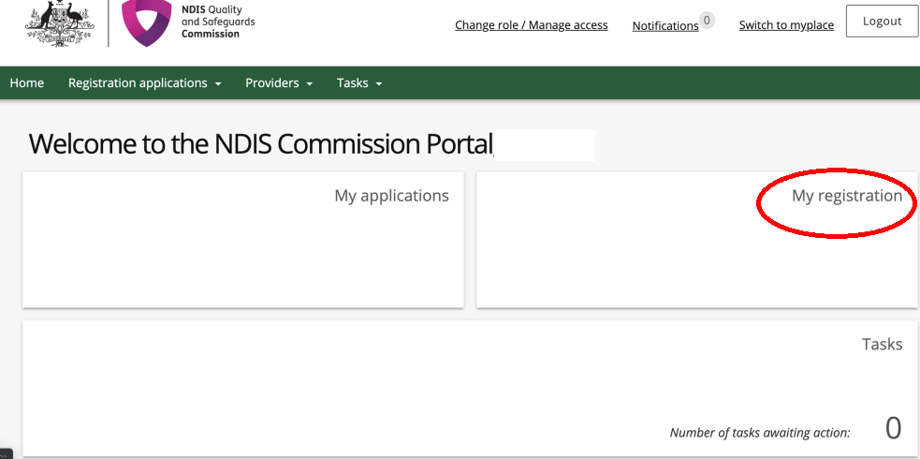

- Select Outlets from the left hand menu under Registration details
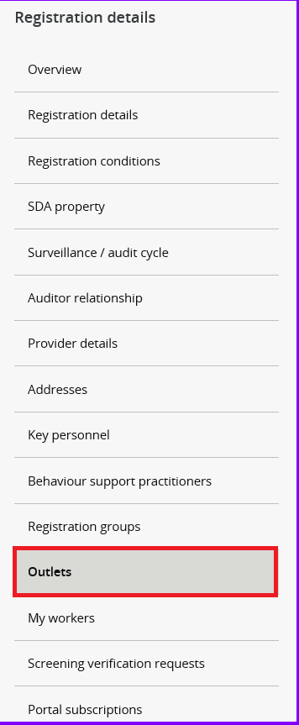
Add outlet
- Click Add

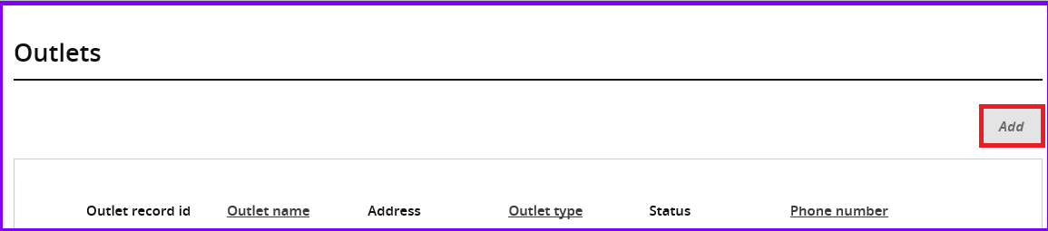

The ‘Add Outlet’ details window opens

- Type the details of the new Outlet and then click ‘Add address’.
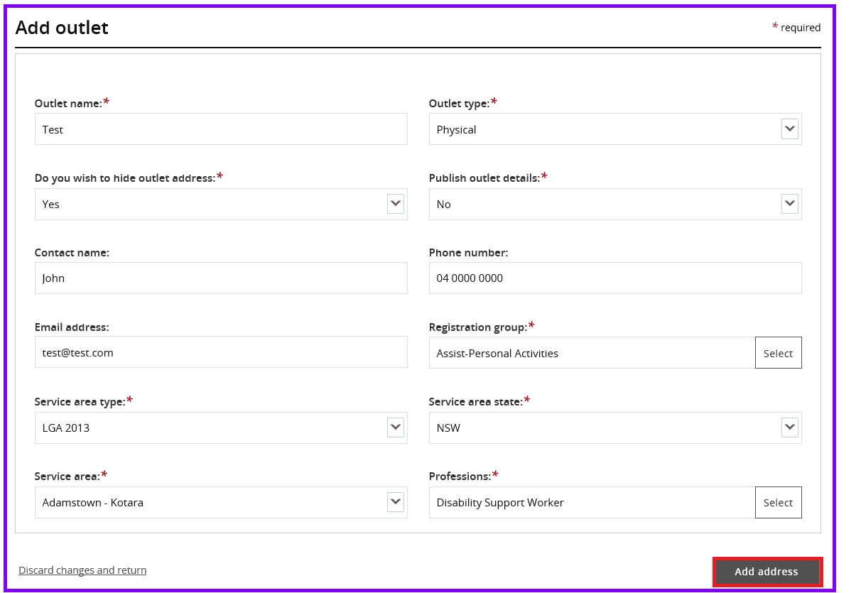
- Select date. If the address does not appear in the drop down, Click ‘I don’t see my address’ and type the address manually. Then Click ‘Save’
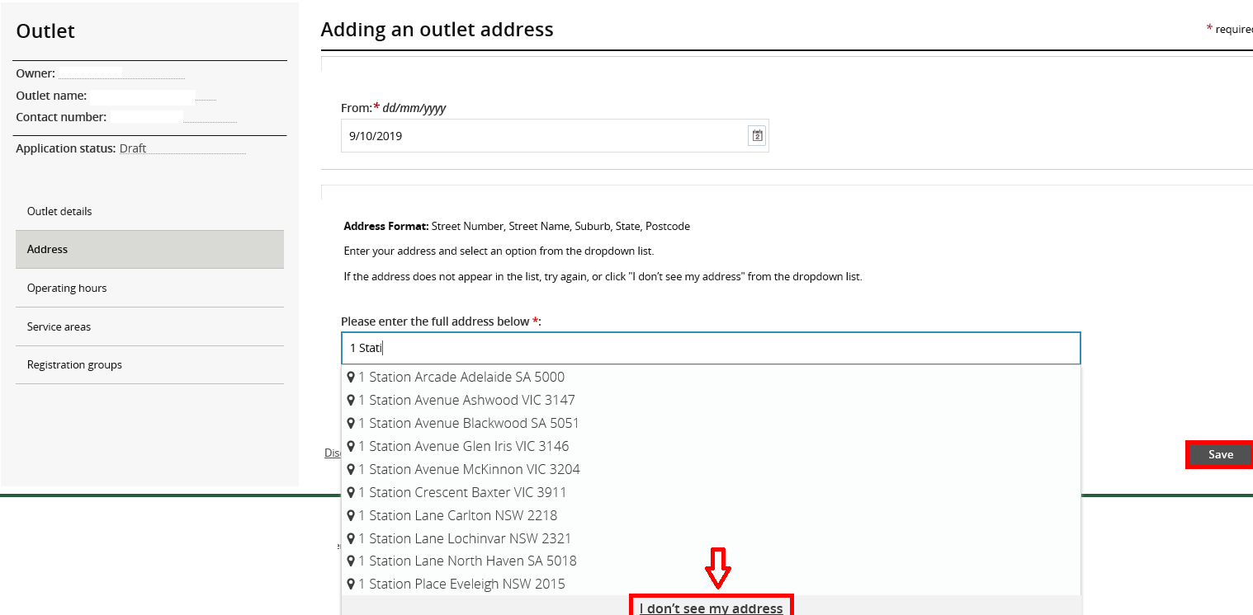

- Add Operating hours for the outlets

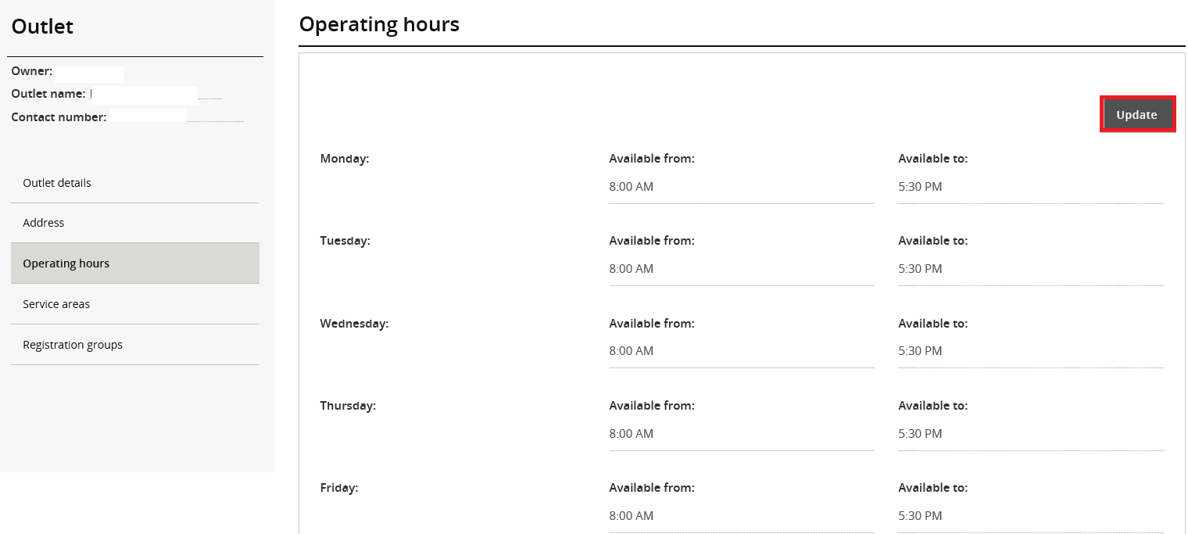
- Add Areas serviced by the outlet. Click on the ‘Add’ button and a selection box appears

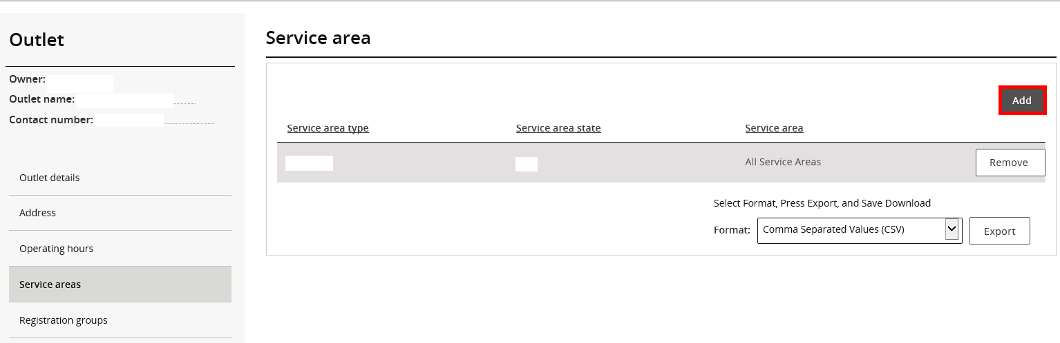

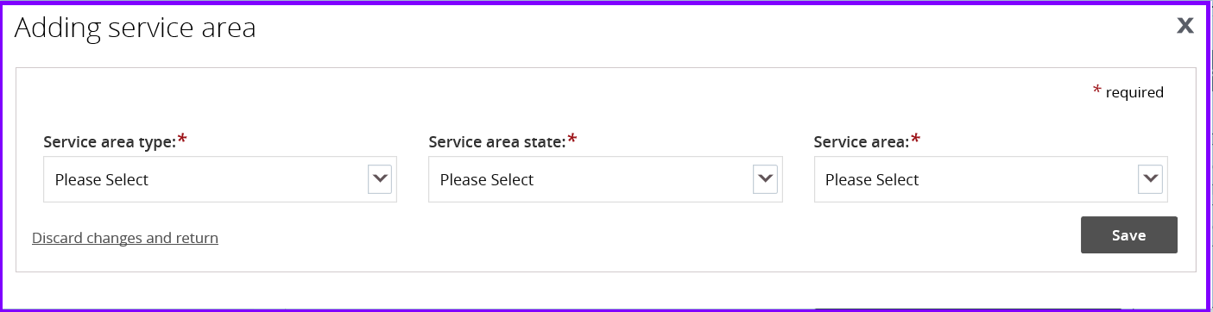

- The service area type will be LGA 2013. Individual service areas would need to added individually as the system does not allow multiple selections. Alternatively, ‘All Service Areas’ option will include all LGAs in the selected State. 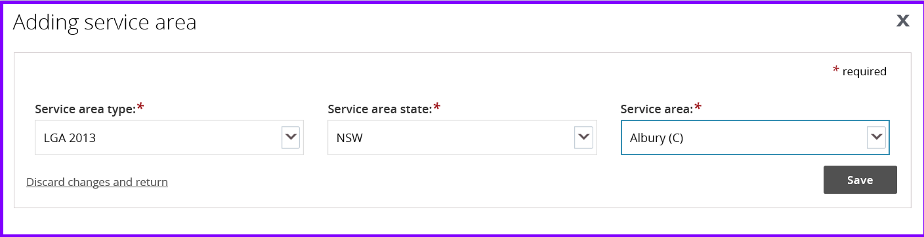Once saved, the steps will need to be repeated to add individual service areas.

- Add Registration groups and Professions serviced by the outlet. There needs to be at least one registration Group associated with each outlet. 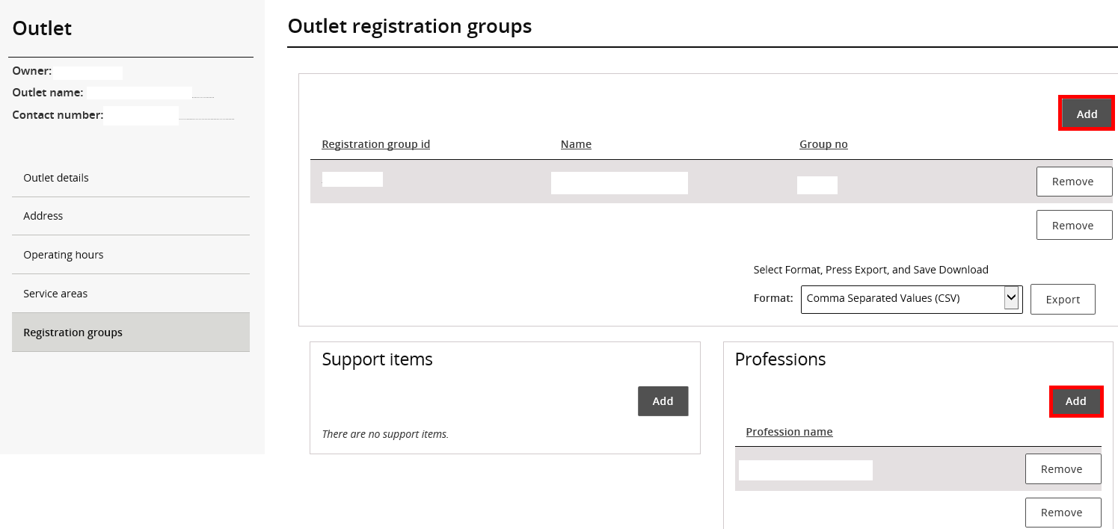

Manage Outlet details
- Click ‘Actions’ and then ‘Manage outlet’ drop down
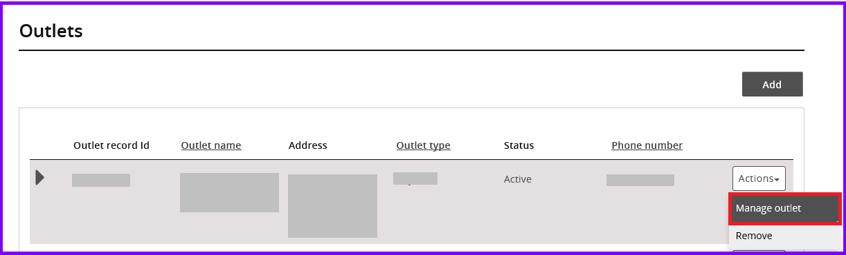
- Select the appropriate tab on the left to make changes and click ‘Update/Add’ button on the right to make changes.

- To update Primary outlet details, click ‘Update outlet’ , enter details and save once completed. To keep your Address confidential on the NDIS Provider Register, Click on ‘Address’ , say ‘Yes’ to Hide outlet address and ‘No’ to Publish outlet details.
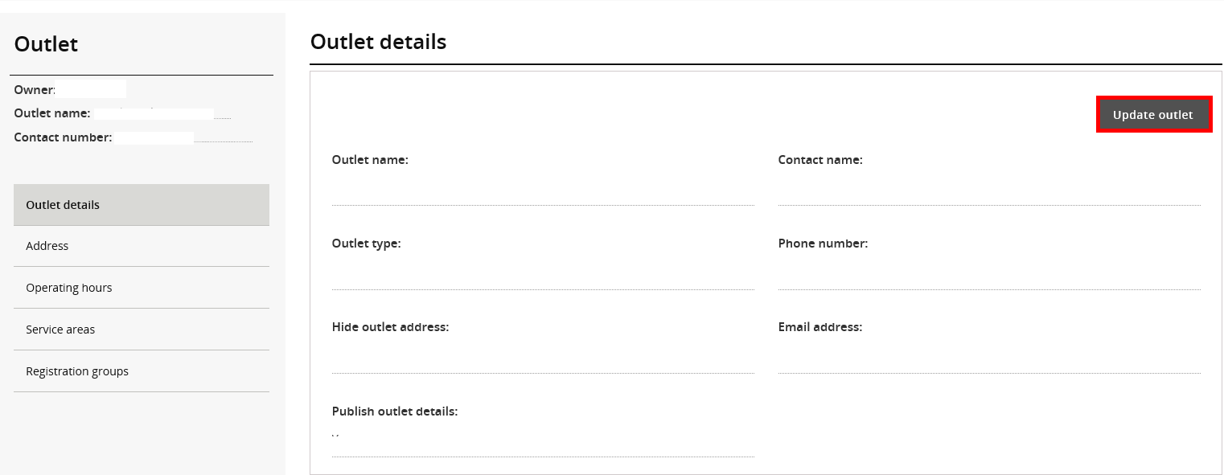

- Update address details ( previous addresses cannot be deleted off the system, they appear as inactive)

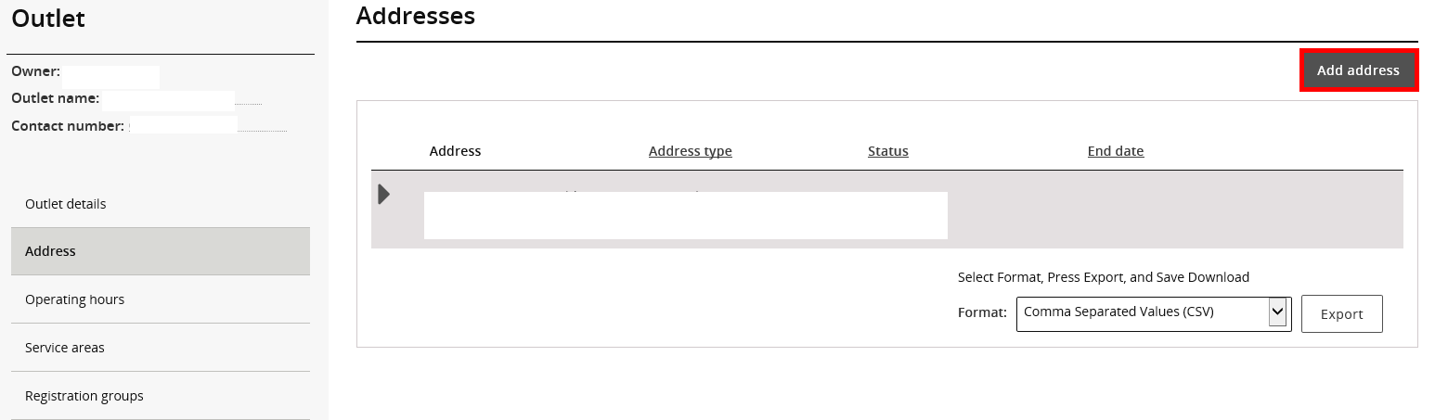
- Operating hours for the outlets

- Areas serviced by the outlet. Select LGA 2013 from Service area type and state. Individual service areas can be selected one at a time.
- Add Registration groups and Professions serviced by the outlet
Removing an outlet

- Click ‘Actions’ and then ‘Remove’ drop down
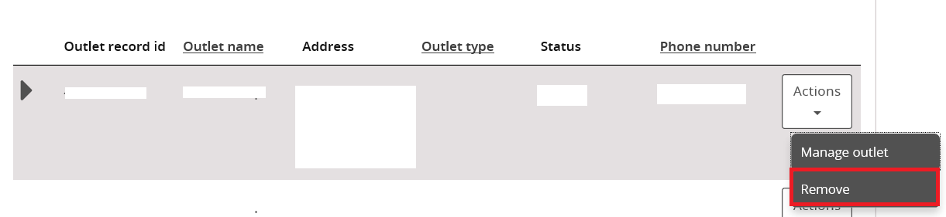

- Once an outlet is removed, the information is not deleted from the system however the status changes to inactive.

