Attach audit documents
Quick Reference Guide - Auditor
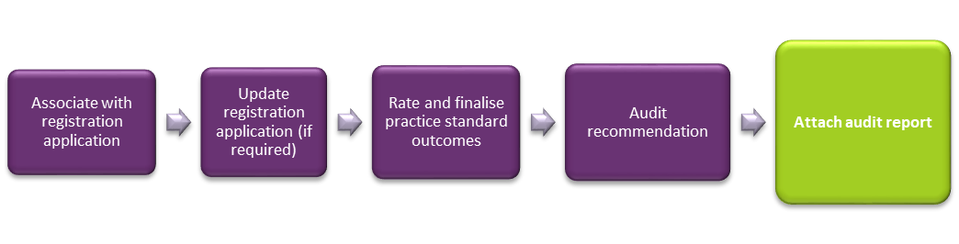
This guide demonstrates how to attach audit documents.

Attach audit documents
- Log into NDIS Commission Portal.
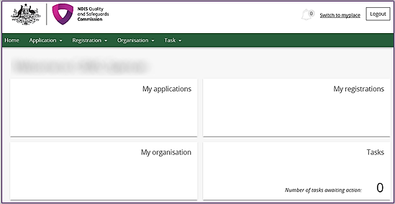

- Select Application then Application list Or Application Search.
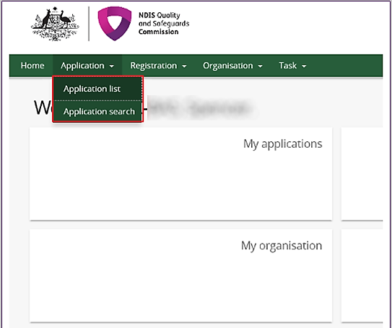

- Select view to open the application.

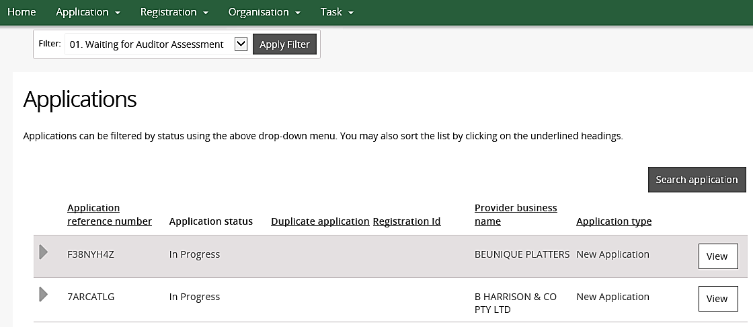
The application opens.

Under the Action heading in the left hand side menu, select Attachments.
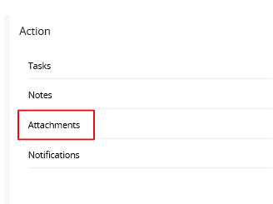
Select add attachment.
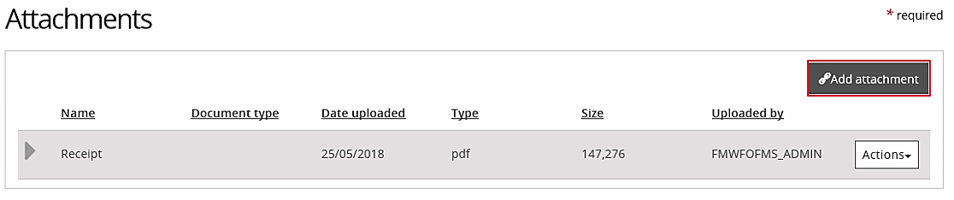

- A pop up window will appear, allowing you to select the document to be attached from your computer.
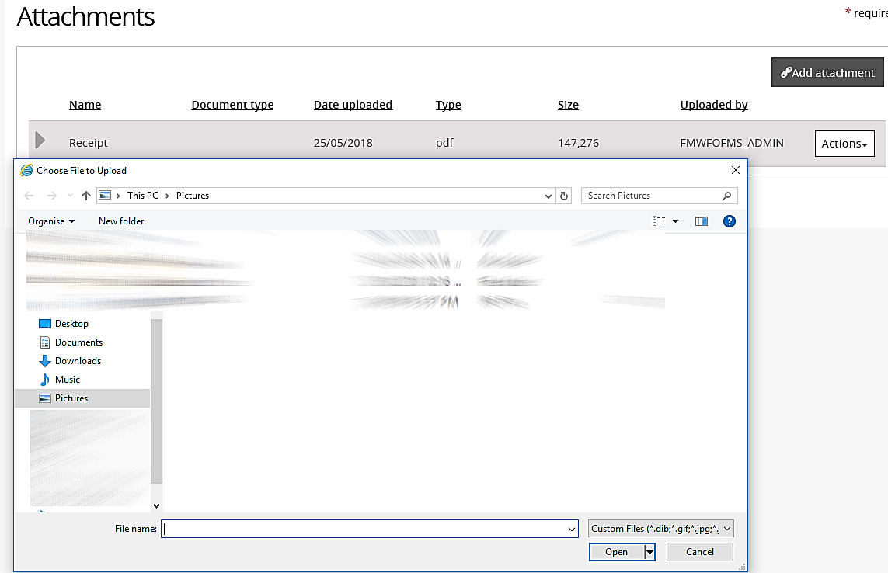
- Complete the attachment details and select the correct document type.
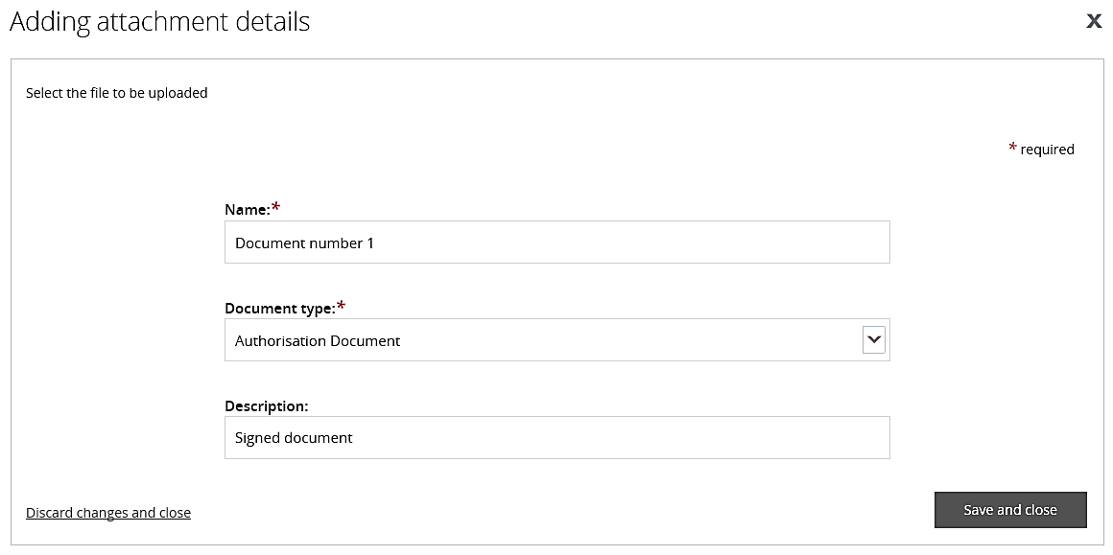

Please Note: Auditors should use the following naming convention when adding documents.
Registration/Application ID_Provider short name_Audit report
Registration/Application ID_Provider short name_Provider audit response
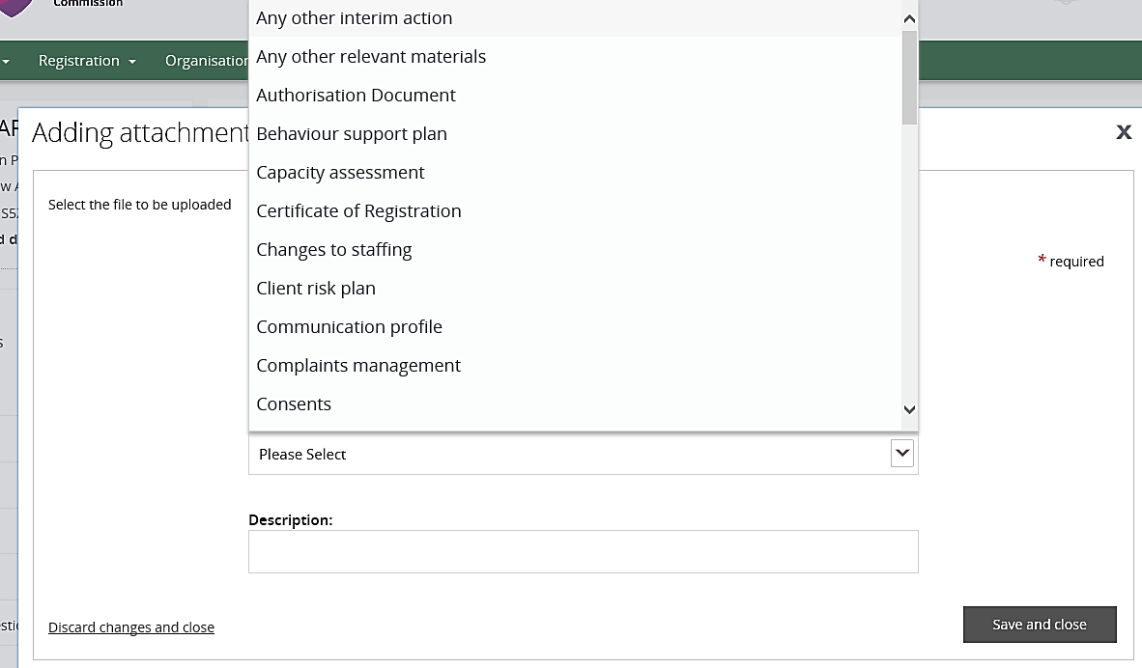
- Select save and close to keep changes.

- The document can now be seen on the Attachments screen. You can download the document, by selecting Actions and clicking Download.
