Audit recommendation
IT Quick Reference Guide – Approved Quality Auditor
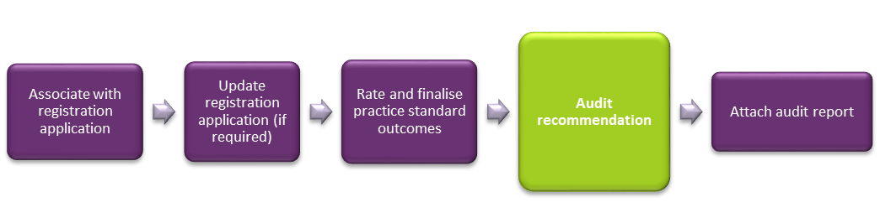
This Quick Reference Guide explains how an auditor records the audit recommendation for a provider’s application for registration with the NDIS Quality and Safeguard Commission.
PLEASE NOTE: There are two system access roles; Auditor and Approved Quality Auditor. A user who has the role of Approved Quality Auditor within the Commission portal can complete this step.

Auditor records audit recommendation
- Click Auditor recommendation on the left hand side menu then click Update.
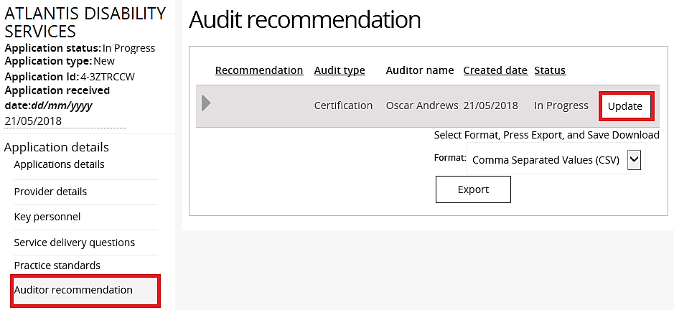

- Select a Recommendation, type any Recommendation comments then click Save.
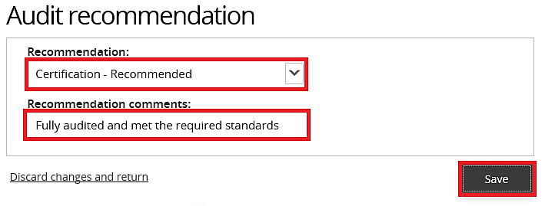

The status of the audit recommendation changes from In Progress to Submitted to Commission.
