Quick reference guide: Find a worker and check their clearance status
Registered provider

Contents
Contents 1
Overview 1
Find a linked worker 2
Check a worker’s clearance status 3

Overview
- The NDIS Worker Screening Database (NWSD) is a national database which stores NDIS Worker Screening Check information about workers who deliver NDIS supports and services.
- Registered NDIS providers must ensure that persons (in risk assessed roles), who are employed or otherwise engaged (worker), have an NDIS Worker Screening Check. This is a statutory requirement and a condition of registration as a registered NDIS provider. More information about this can be found on our website - Worker screening requirements (NDIS registered providers).
- When a worker applies for a NDIS Worker Screening Check they must nominate an employer/s to verify their application. Once verified, the worker will be linked to the employer and the employer will be able to view the worker’s record. The employer will also receive updates about the worker’s NDIS Worker Screening Check status.
- This quick reference guide provides information about how to find a linked worker and check their NDIS Worker Screening Check status.
For further information please refer to the NDIS Quality and Safeguards Commission website - Worker screening requirements (NDIS registered providers). Alternatively, contact the NDIS Quality and Safeguards Commission on 1800 035 544 or by email at nwsd@ndiscommission.gov.au.

Find a linked worker
- Log into the NWSD and select the ‘Worker Screening’ section, then navigate to the ‘My workers’ tab.
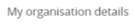
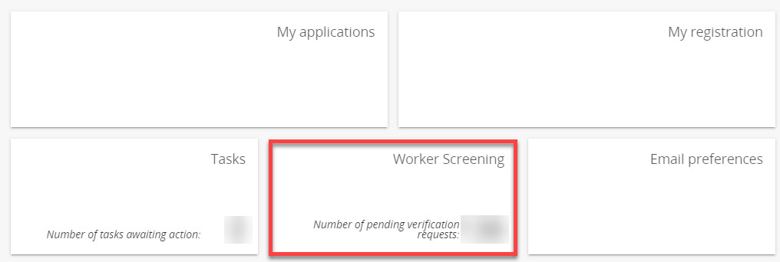
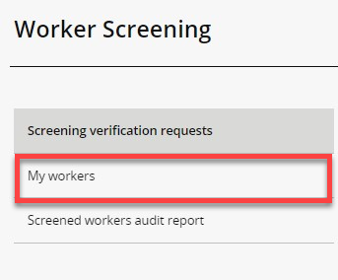
- To find a worker select search and enter any of the worker’s details you have available. Select ‘Run search’.
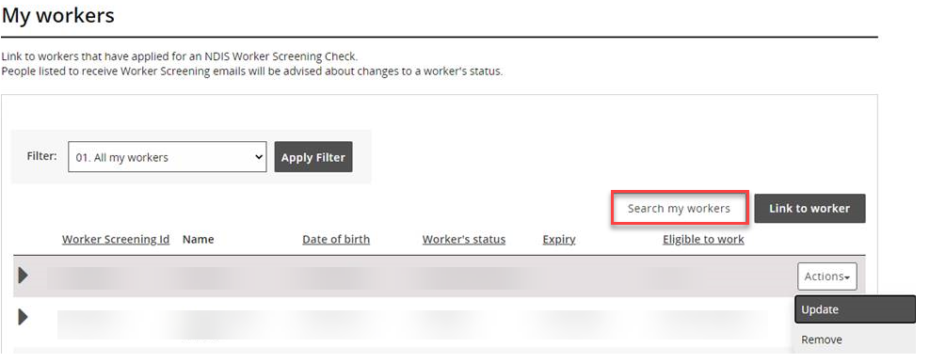
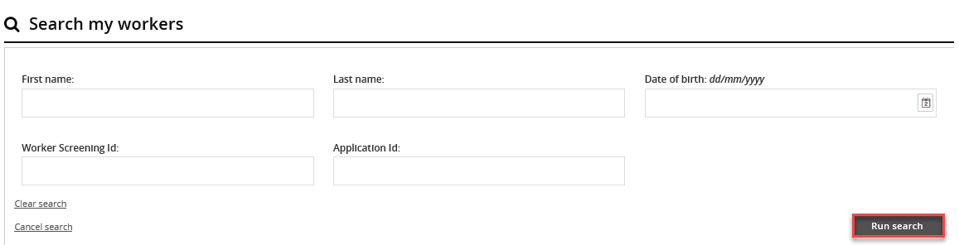
123456789
LAST NAME
- Alternatively, you can filter the list of workers by selecting ‘Filter’ and ‘Apply Filter’ and/or sort the columns selecting the column heading.
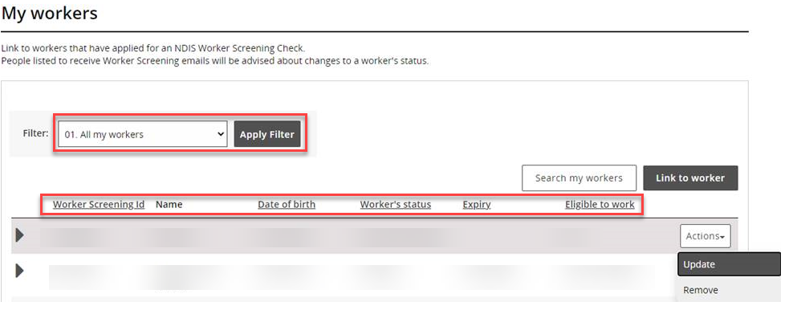
Tip 1 – To view all of your linked workers in a spreadsheet, either export a list from the NWSD by selecting a ‘Format’ from the dropdown (Tab Separated Values (TSV) is recommended) and ‘Export’, or go to the ‘Screened workers audit report’ option on the side bar.
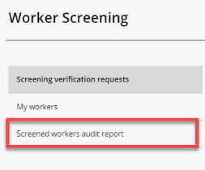
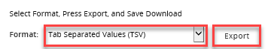

Check a worker’s screening status
- Navigate to the ‘My workers’ tab and find the worker you want to check the screening status of.
0
Tip 2 – Refer to the ‘Find a worker’ section of this quick reference guide.
- Check the worker’s status, expiry date and eligible to work details to ensure they have a current NDIS Worker Screening Clearance.
Tip 3 – For a worker to have a current NDIS Worker Screening Clearance, their ‘Worker’s status’ must be ‘Clearance’, ‘Expiry date’ set to a date in the future, and ‘Eligible to work’ status set to ‘Yes’.
0
Tip 4 – You will receive email notifications about your linked workers regarding their NDIS Worker Screening screening status:
0
- 90 days prior to when their NDIS Worker Screening Clearance is due to expire; and
- if there is a NDIS Worker Screening Clearance status change e.g. they have been excluded and are no longer eligible to work.

