Quick reference guide: Unlink a worker
Registered provider

Contents
Contents 1
Overview 1
Find a linked worker 2
Unlink a worker 2

Overview
- The NDIS Worker Screening Database (NWSD) is a national database which stores NDIS Worker Screening Check information about workers who deliver NDIS supports and services.
- Registered NDIS providers must ensure that persons (in risk assessed roles), who are employed or otherwise engaged (worker), have an NDIS Worker Screening Check. This is a statutory requirement and a condition of registration as a registered NDIS provider. More information about this can be found on our website - Worker screening requirements (NDIS registered providers).
- When a worker applies for a NDIS Worker Screening Check they must nominate an employer/s to verify their application. Once verified, the worker will be linked to the employer and the employer will be able to view the worker’s record and will receive updates about the worker’s clearance status.
- Once a worker is no longer delivering NDIS supports and services for a Registered NDIS Provider the link to the worker in the NWSD must be removed (unlink).
- This quick reference guide provides information about how to unlink a worker that no longer delivers NDIS supports and services for your organisation.
For further information please refer to the NDIS Quality and Safeguards Commission website - Worker screening requirements (NDIS registered providers). Alternatively, contact the NDIS Quality and Safeguards Commission on 1800 035 544 or by email at nwsd@ndiscommission.gov.au.

Find a linked worker
- Log into the NWSD and select the ‘Worker Screening’ section, then navigate to the ‘My workers’ tab.

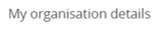
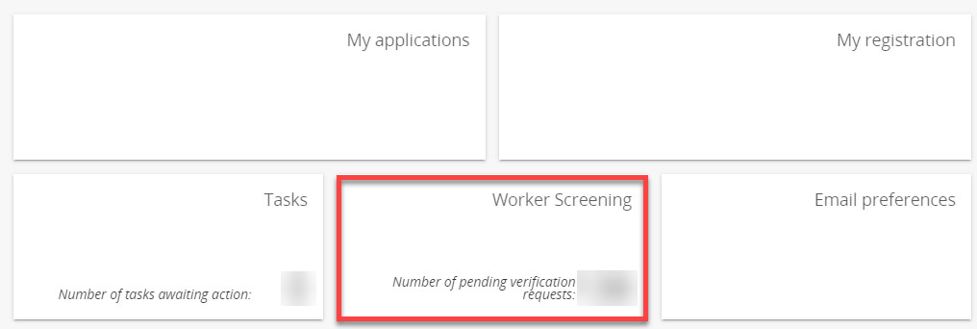
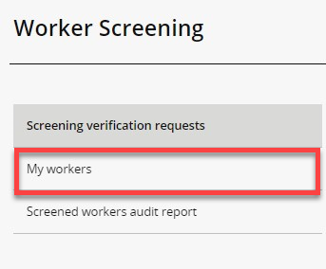
- To find a worker select search and enter any of the worker’s details you have available. Select ‘Run search’.
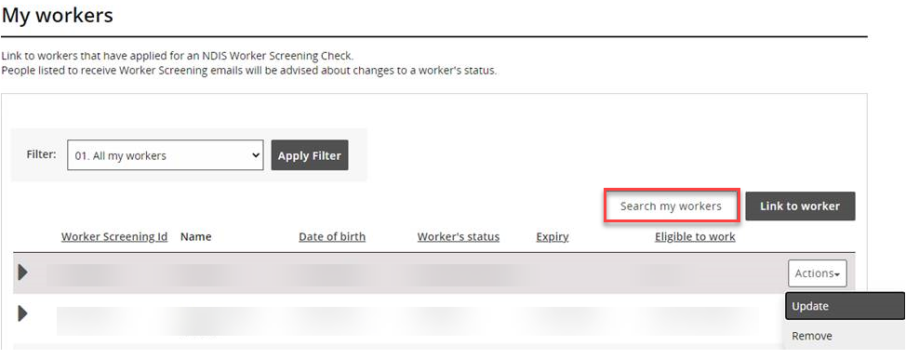
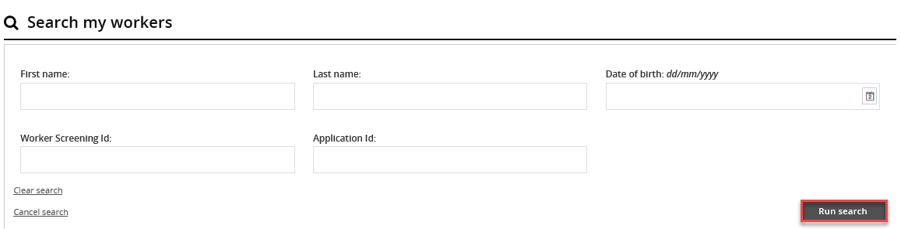
123456789
LAST NAME
- Alternatively, you can filter the list of workers by selecting ‘Filter’ and ‘Apply Filter’ and/or sort the columns selecting the column heading.
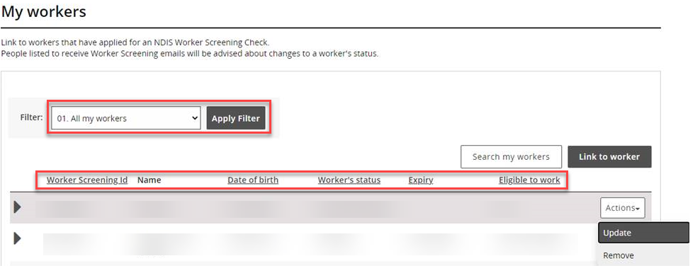

Unlink a worker
- If a worker is no longer delivering NDIS services and supports for your organisation, unlink them from your organisation.
Tip 2 – You may need to unlink a worker if they no longer work for you, or if you have accidentally verified a worker.
- Navigate to the ‘My workers’ tab, locate the worker and select ‘Actions’ and ‘Remove’.
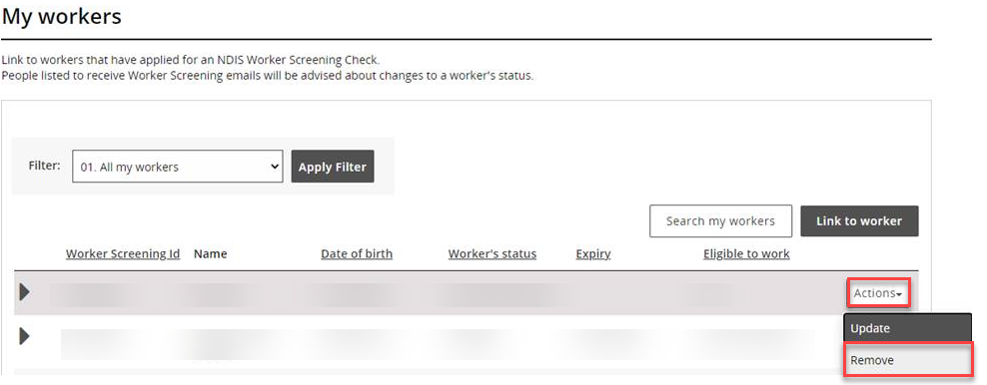
- Select ‘Remove’ if you are sure you want to unlink the worker. You will no longer be able to view the worker record and won’t receive any screening status update about the worker.

