Managing My Reportable Incidents
Quick Reference Guide – Reportable Incidents
Using the My Reportable Incidents page on the NDIS Commission Provider Portal, providers are able to download the list of their open and/or completed Reportable Incidents notifications for internal use and/or storage.
This guide outlines the steps for:
- Downloading the list of reportable incident notifications
Before getting started, some useful hints and tips are outlined below:
Tip 1 – Ensure that you have the right access to download the list of Reportable Incidents.
- The Provider Authorised RI Approver will be able to access and download the list of all reportable incidents relevant to the provider organisation
- The Provider Authorised RI Notifier will only be able to access and download the list of all reportable incidents that they have created or been assigned to in the system
Please review the Quick reference guide - getting access to NDIS Portal to ensure you understand the responsibilities of each role and how to set up/ change these within your organisation.
- For further information/ questions, please contact the NDIS Commission Contact Centre on 1800 035 544 or by email: contactcentre@ndiscommission.gov.au
- To provide feedback on the reportable Incidents portal, please contact the NDIS Commission via riportalfeedback@ndiscommission.gov.au

Downloading the List of Reportable Incident Notifications
Please ensure that you are logged into the Portal as either the Provider Authorised RI Approver or the Provider Authorised RI Notifier. For information on how to log in or definitions of these roles, please see Quick reference guide - getting access to NDIS Portal
- Click on the My Reportable Incidents tile.
Figure 1: Screenshot of My Reportable Incidents page demonstrating Step 1
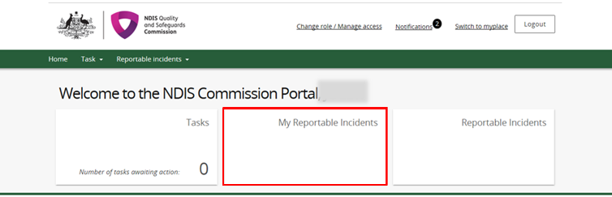
- Select My Reportable Incidents or All Reportable Incidents from the drop down list. Click Apply Filter.
- My Reportable Incidents will populate the list of reportable incidents that you have created or been assigned in the system
- All Reportable Incidents will populate the list of all reportable incidents relating to your provider organisation. Note that the Provider Authorised RI Notifier will only be able to access ‘My Reportable Incidents’.
Figure 2: Screenshot of My Reportable Incidents page demonstrating Step 2
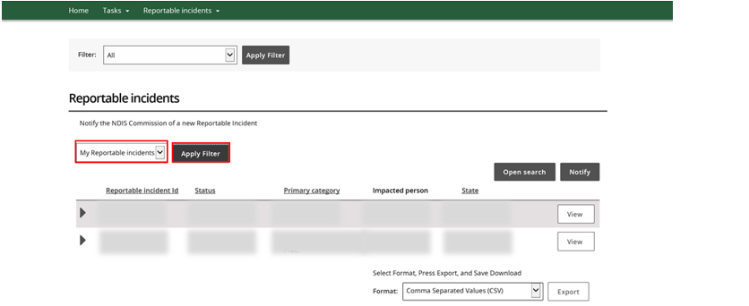
- Select the Format from the drop down menu. Click Export and save/open the file as required.
Figure 3: Screenshot of My Reportable Incidents page demonstrating Step 3
