Quick reference guide: Find a worker and check their clearance status
Unregistered provider, self-managed participant & plan-managed participant

Contents
Contents 1
Overview 1
Find a linked worker 2
Check a worker’s clearance status 4

Overview
- The NDIS Worker Screening Database (NWSD) is a national database which stores NDIS Worker Screening Check information about workers who deliver NDIS supports and services.
- Unregistered NDIS providers, self-managed participants (SMPs) and plan-managed participants (PMPs) can decide whether they will require their workers to have an NDIS Worker Screening Check. More information about this can be found on our website – Unregistered providers and Worker Screening (self-managed and plan-managed participants).
- When a worker applies for an NDIS Worker Screening Check they must nominate an employer/s to verify their application. An employer in this regard may include an unregistered provider, self-managed or plan-managed NDIS participant. Once verified, the worker will be linked to the employer and the employer will be able to view the worker’s record. The employer will also receive updates about the worker’s NDIS Worker Screening Check status.
- This quick reference guide provides information about how to find a linked worker and check their NDIS Worker Screening Check status.
For further information please refer to the NDIS Quality and Safeguards Commission website
(Unregistered providers and Worker Screening (self-managed and plan-managed participants)). Alternatively, contact the NDIS Quality and Safeguards Commission on 1800 035 544 or by email at nwsd@ndiscommission.gov.au.

Find a linked worker
- Log into PRODA and select ‘Worker Screening for NDIS Participants’ (for self-managed and plan-managed participants) or ‘Worker Screening for Organisation’ (for unregistered providers) to access the NWSD.
Tip 2 - Refer to the Quick reference guide – Unregistered Provider – Request access to the NWSD or Quick reference guide – SMP & PMP – Request access to the NWSD.
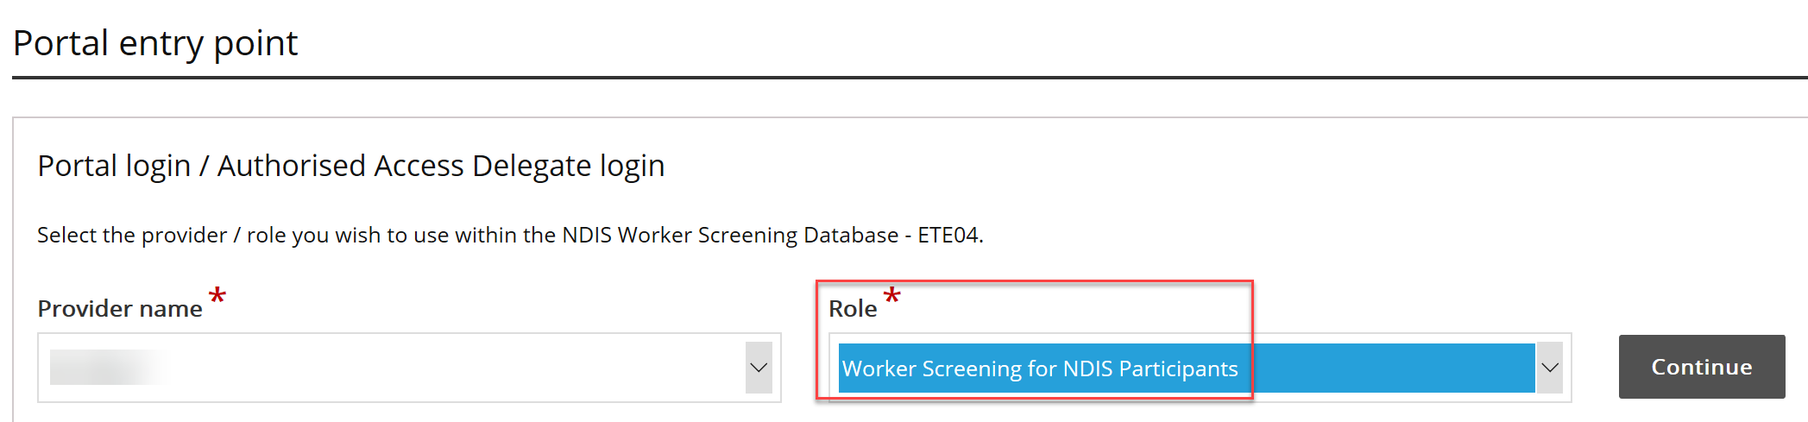
- Navigate to the ‘My workers’ tab.
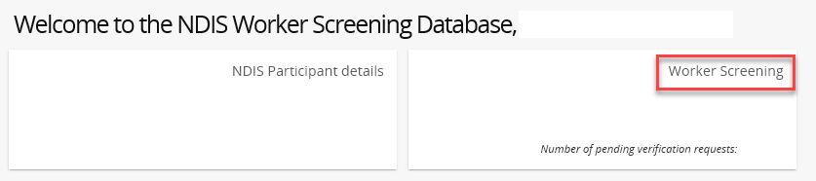
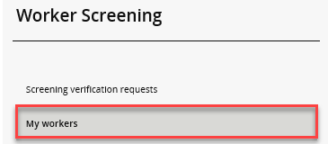
- To find a worker select search and enter any of the worker’s details you have available. Select ‘Run search’.
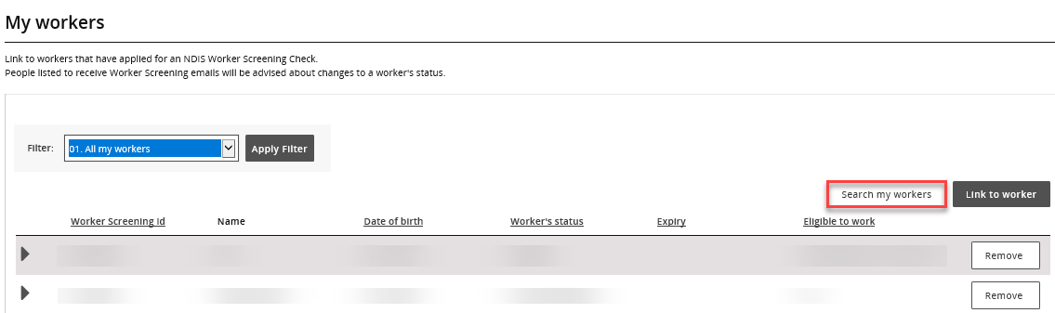
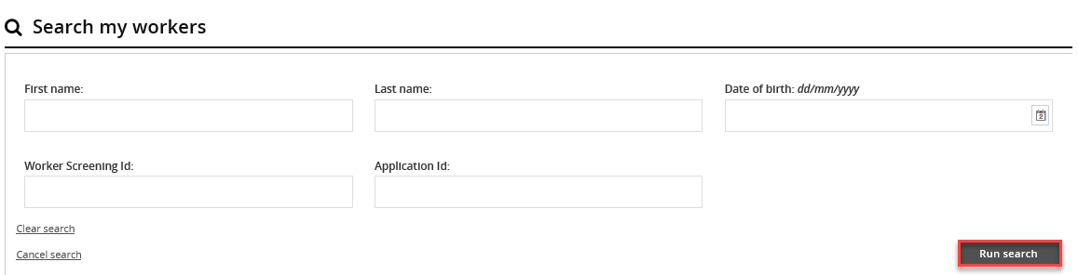

- Alternatively, you can filter the list of workers by selecting ‘Filter’ and ‘Apply Filter’ and/or sort the columns selecting the column heading.
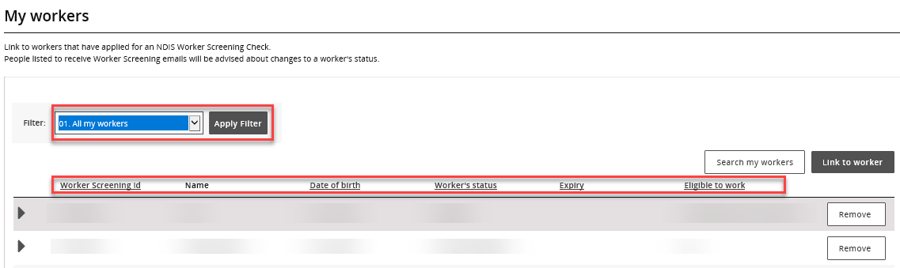
Tip 2 – To view all of your linked workers in a spreadsheet, export a list from the NWSD by selecting a ‘Format’ from the dropdown (Tab Separated Values (TSV) is recommended) and selecting ‘Export’.
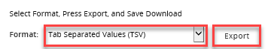

Check a worker’s screening status
- Navigate to the ‘My workers’ tab and find the worker you want to check the NDIS Worker Screening Check status of.
Tip 3 – Refer to the ‘Find a worker’ section of this quick reference guide.
0
- Check the worker’s NDIS Worker Screening Check status, expiry date and eligible to work details to ensure they have a current NDIS Worker Screening Clearance.
Tip 4 – For a worker to have a current NDIS Worker Screening Clearance, their ‘Worker’s status’ must be ‘Clearance’, ‘Expiry date’ set to a date in the future, and ‘Eligible to work’ status set to ‘Yes’.
0
Tip 5 – You will receive email notifications about your linked workers regarding their NDIS Worker Screening status:
0
- 90 days prior to when their NDIS Worker Screening Clearance is due to expire;
- if there is a NDIS Worker Screening Clearance status change e.g. they have been excluded and are no longer eligible to work.

