Using the Behaviour Support Practitioner Admin role to lodge behaviour support plans
The ‘Behaviour Support Practitioner Admin’ has been created to support specialist behaviour support providers to lodge behaviour support plans in the NDIS Commission Portal.

What does the Behaviour Support Practitioner Admin role do?
The new Behaviour Support Practitioner Admin role allows an admin staff member or other non- behaviour support practitioner staff member to lodge behaviour support plans on behalf of the specialist behaviour support practitioner.
However, a behaviour support practitioner must be added to the behaviour support plan in the NDIS Commission Portal, and remains responsible for the information entered into the Portal and contained in the behaviour support plan. The Behaviour Support Practitioner Admin can complete all steps required for lodgement; however, the behaviour support practitioner must complete the final step of verifying that the plan has been entered correctly and clicking the Send draft button.

Using the Behaviour Support Practitioner Admin role
The first step is to request access for the ‘Behaviour Support Practitioner Admin’ role. The authorised access delegate can approve access for this role.

Step-by-step guide to using the Behaviour Support Practitioner Admin role
Below are instructions with screen shots to assist you to use the Behaviour Support Practitioner Admin role. These steps should be read in conjunction with the NDIS Commission Portal User Guide for Behaviour Support.
- Click on the Behaviour support plan drop-down menu and select Behaviour support plan list.
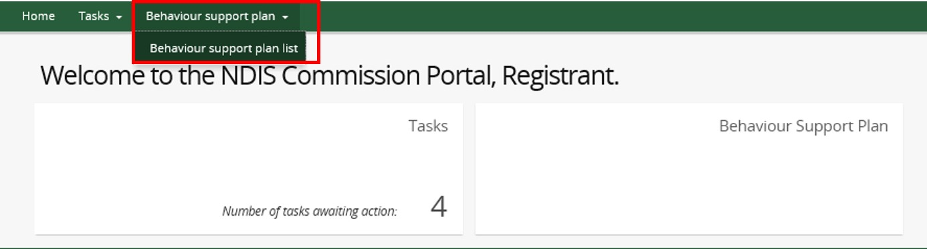
- Click Create plan.
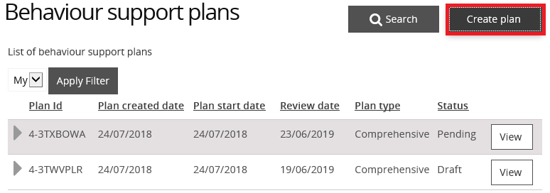
- Continue to enter the plan information as per the NDIS Commission Portal User Guide for Behaviour Support.
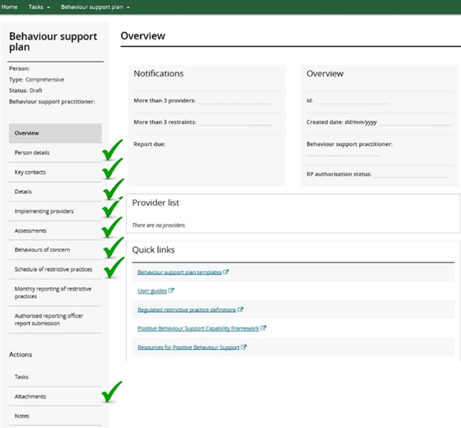
- Select the Details page and click Update. This will then allow you to update any information on that page.
- Link the plan to the behaviour support practitioner who wrote it by clicking the Select button. Then search by name and select the practitioner. Once selected, this will populate the relevant fields. Add the plan start and end dates on this screen.
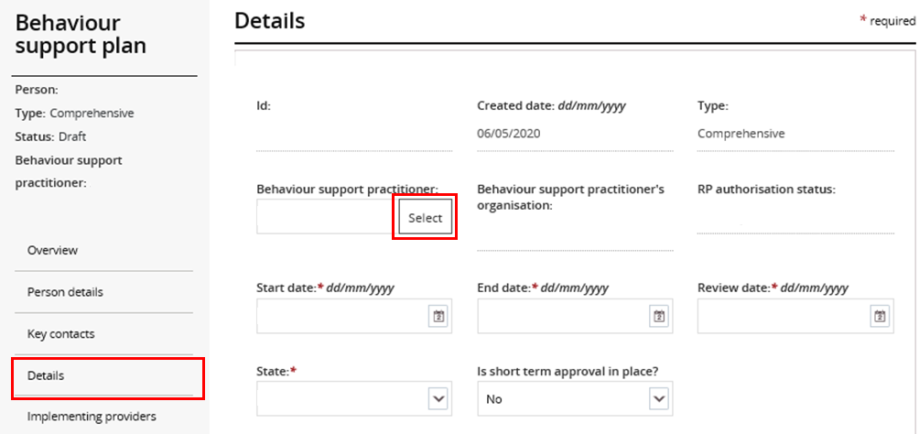
- Once you have entered all the plan information, go to the Details page on the left hand side navigation menu, and click Validate. If there are any mandatory fields not completed, an error message will be displayed.
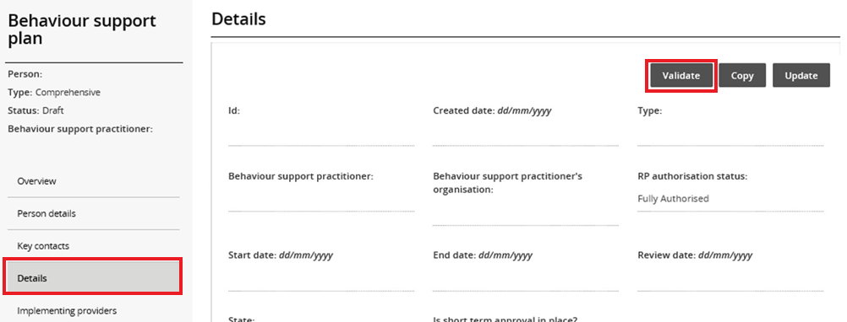
- When all the required information has been completed and the validate button is clicked, the “Validations successful” message will be displayed.
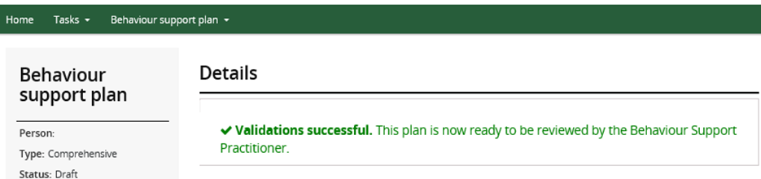
The plan has now been saved and is ready for the behaviour support practitioner to review.
- The behaviour support practitioner should log in and verify that the plan has been entered correctly. They should also ensure that a copy of the plan is attached.
They can then click the Send draft button, which is located at the top right hand side of the Details view and is displayed when the user is logged in as Behaviour Support Practitioner.
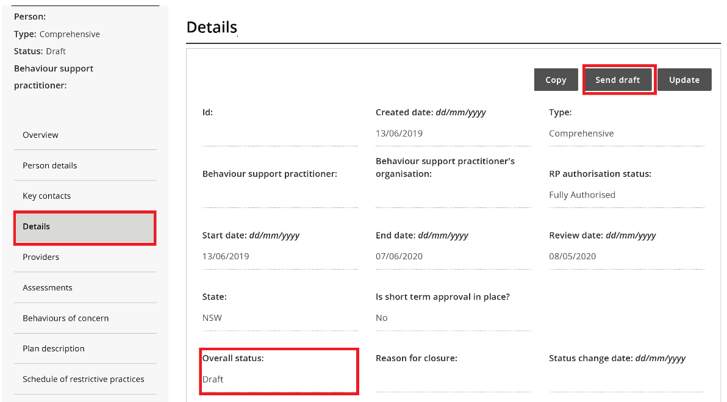
This will change the plan status to ‘pending’ and allow the implementing provider to accept the plan and commence monthly reporting.

Contact us
Call: 1800 035 544 (free call from landlines). Our contact centre is open 9.00am to 4.30pm in the NT, 9.00am to 5.00pm in the ACT, NSW, QLD, SA, TAS and VIC Monday to Friday, excluding public holidays.
Email: contactcentre@ndiscommission.gov.au
Website: www.ndiscommission.gov.au

