Quick reference guide
NDIS Commission Provider Portal Inbox
Registered NDIS Provider

Contents
Contents 1
Inbox notification 2
Access the Inbox 3
View inbox messages 6
Search or filter messages 8
Identify who has viewed a message 9

- The NDIS Commission is changing the way it communicates with registered NDIS providers about NDIS Provider Registration and NDIS Worker Screening matters.

- From 12 June 2022, registered NDIS providers will receive a notification to their email account alerting them to a message in their NDIS Commission Provider Portal Inbox.

- NDIS providers will still receive other communication from the NDIS Commission directly, including in relation to reportable incidents, complaints, behaviour support, compliance and investigation matters.

- Regularly check your NDIS Commission Provider Portal Inbox for important messages about your registration and worker screening.

- This quick reference guide provides information about how to access and manage messages in your NDIS Commission Provider Portal Inbox.

Inbox notification
- When you receive a message in your NDIS Commission Portal Inbox you will receive an email alert about the message.
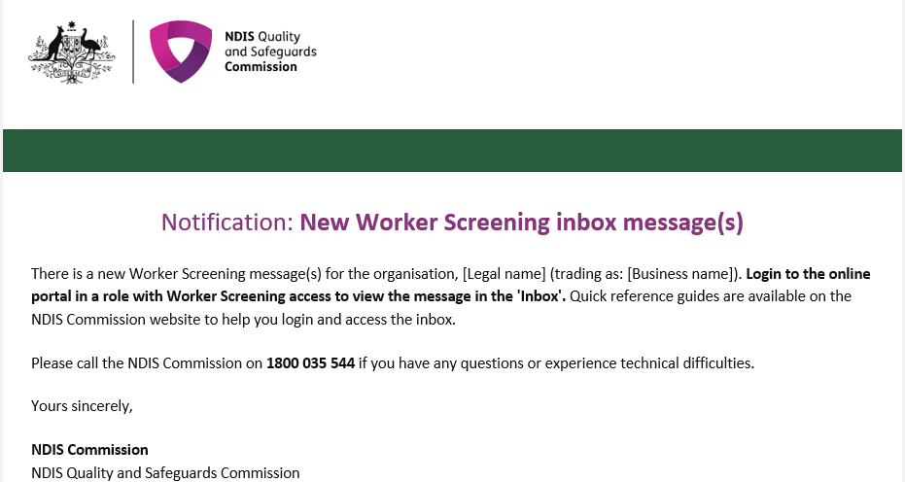
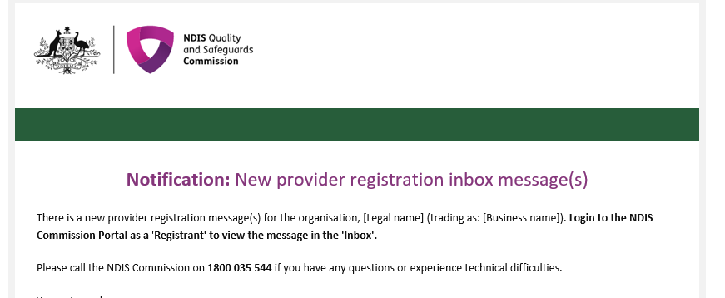
- The representatives that will receive the email alert are those with the email preference of ‘Default recipient’, ‘Registrant’ and/or ‘Worker Screening’.

- For information about how to manage email preferences for worker screening please refer to the QRG - https://www.ndiscommission.gov.au/document/2721

- Email alerts are sent at 6am, 12 noon and 4pm daily (if messages are available). If an inbox message is read before the email alert about that message is sent, an email alert won’t be sent.

For example, if a representative of the organisation opens the inbox at 9.30am and reads a message before the next email alert is sent at 12 noon, an email alert about the message will not be sent. Other representatives of the organisation will need to check the inbox regularly to ensure that all messages are viewed, as they won’t receive the email alert for the message that their colleague has read before the next email alert batch was sent.

Access the Inbox
- Go to the NDIS Commission Website and select the ‘Portals’ button and ‘Registered NDIS providers’ option.
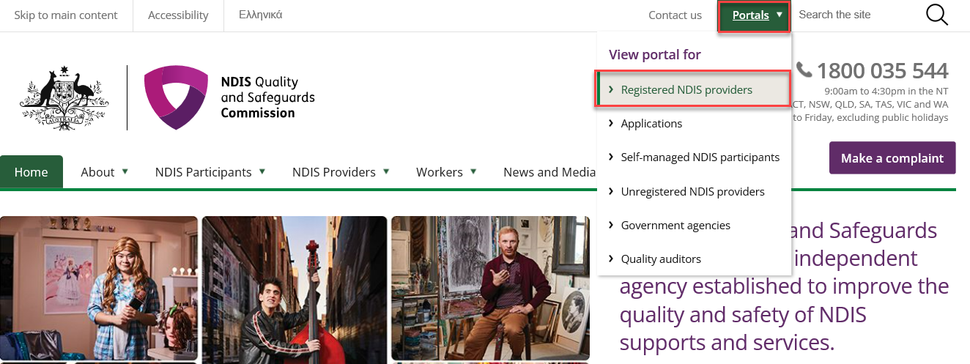

- Select ‘Login with PRODA’.
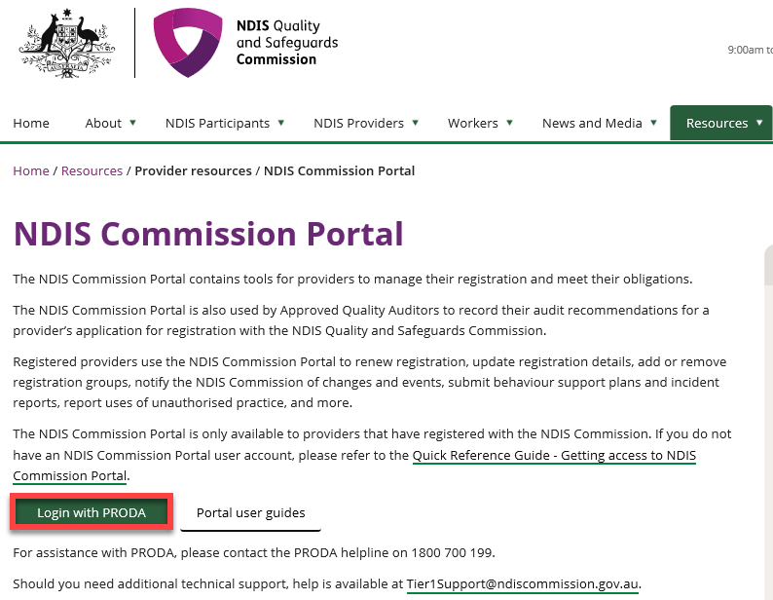
- At the ‘Portal entry point’ select the ‘Provider name’ of the registered NDIS provider that you are logging into the NDIS Commission Portal on behalf of. Select either ‘Worker screening officer’ or ‘Registrant’ as the ‘Role’.
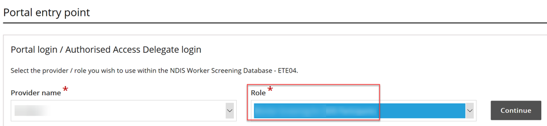

- Select the Inbox tile.
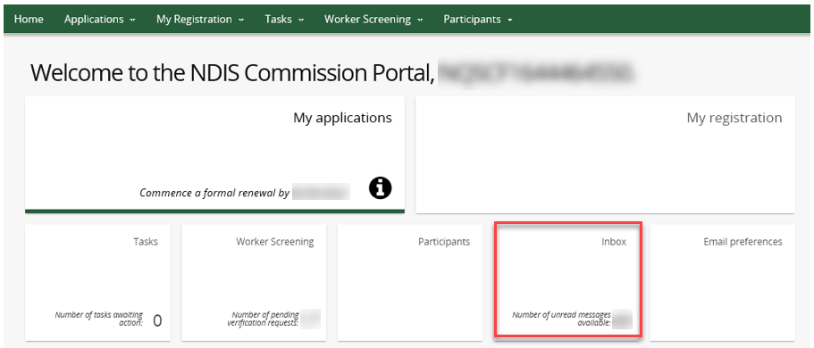
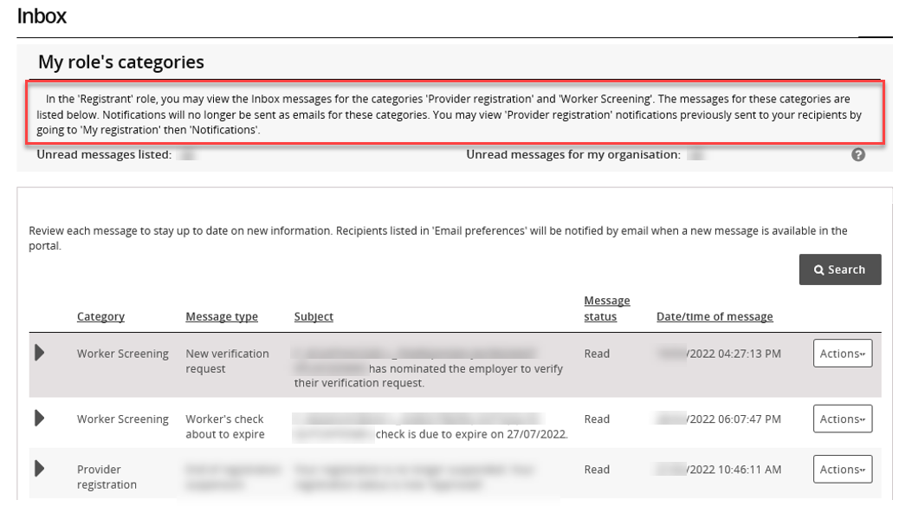
Tip – You can view ‘Provider registration’ notifications previously sent to your registration by going to ‘My registration’ then ‘Notifications’.

View inbox messages
- To view a message select ‘Actions’ and ‘View’.
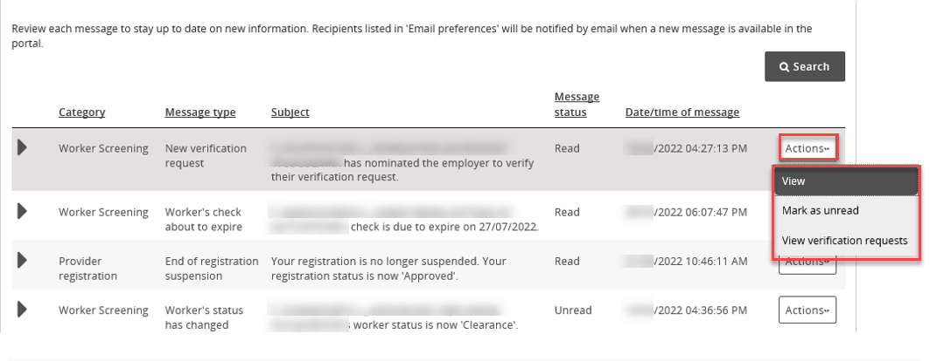
- The message will appear at the bottom of a new page along with information about the message, such as who has viewed it and what email addresses received the email alert about the new message.
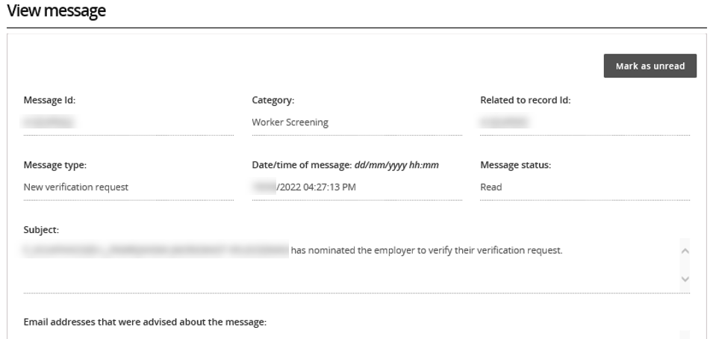
- The message will appear at the bottom of the page. Use the buttons along the top of the message to expand or print the message.

- If the message relates to a worker screening verification request, select ‘View verification requests’ button to navigate directly to the verifications page.
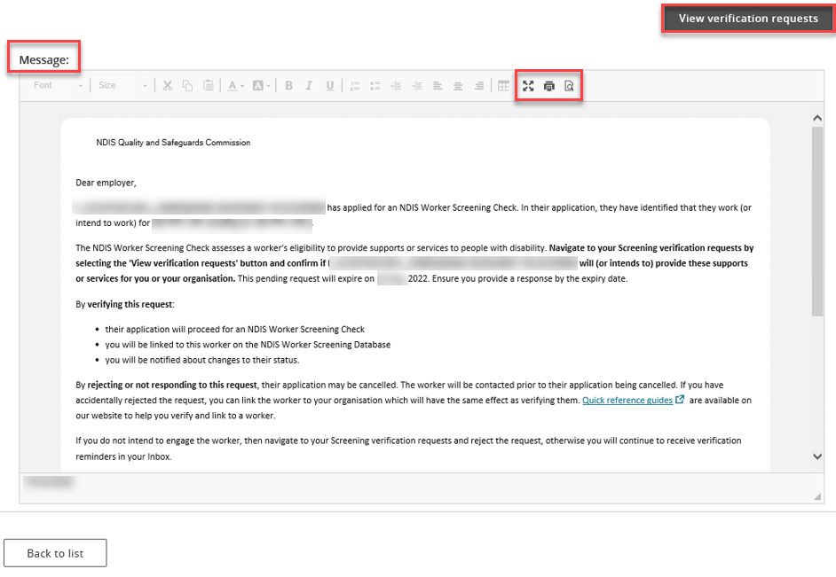

Search or filter messages
- Use the filter options to show only read or unread messages in your inbox, or use the search function to display only particular messages e.g. all messages about Worker Screening.
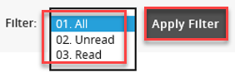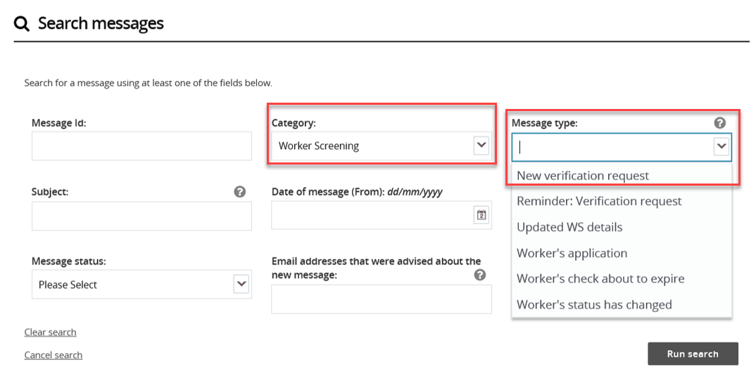

Identify who has viewed a message
- Expand the message in the inbox using the twistie arrow to view who has read the message and at what date/time.

- If a user views a message and then marks it as ‘Unread’, their details will still appear in the ‘Message first read by’ field.

- The ‘Email addresses advised of the message’ lists those email addresses that received the email alert about the message being available in the inbox.

