Add or manage key personnel
Quick reference guide – Provider registration
Providers can add or manage their own key personnel in the NDIS Commission Portal.

Adding a key personnel
- Log in to the NDIS Commission’s business application system using the Registrant role
- Select the My Registration tile
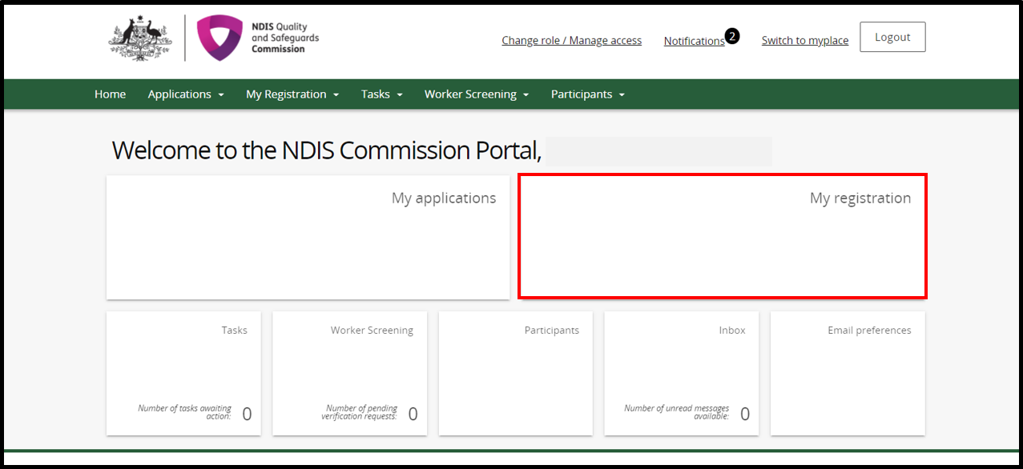
- Select the Key personnel tab from the left hand menu
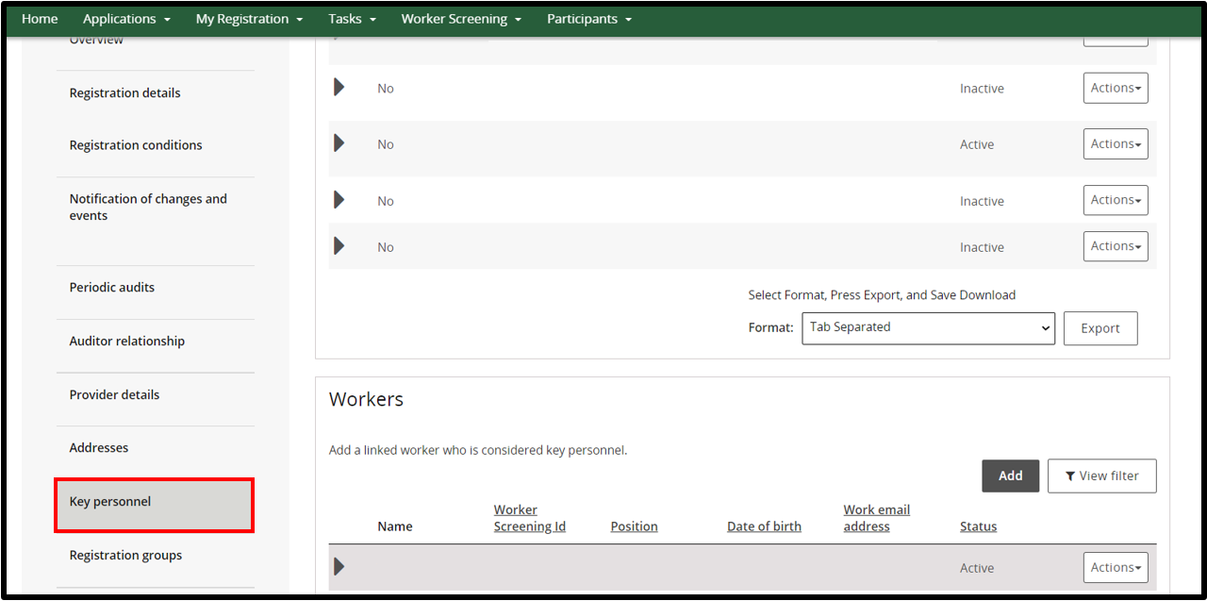
- In the Key personnel window select Add
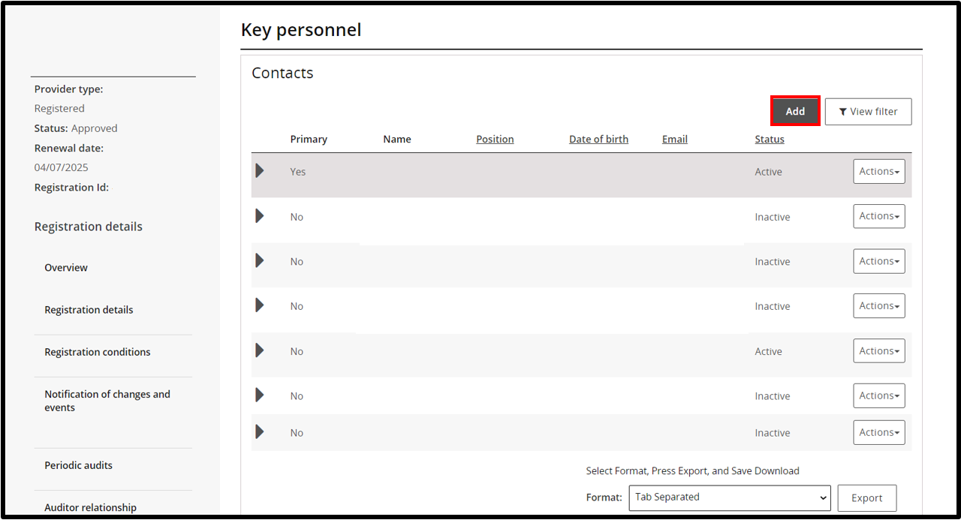
- In the Add/update key personnel window complete the details and select Save and continue
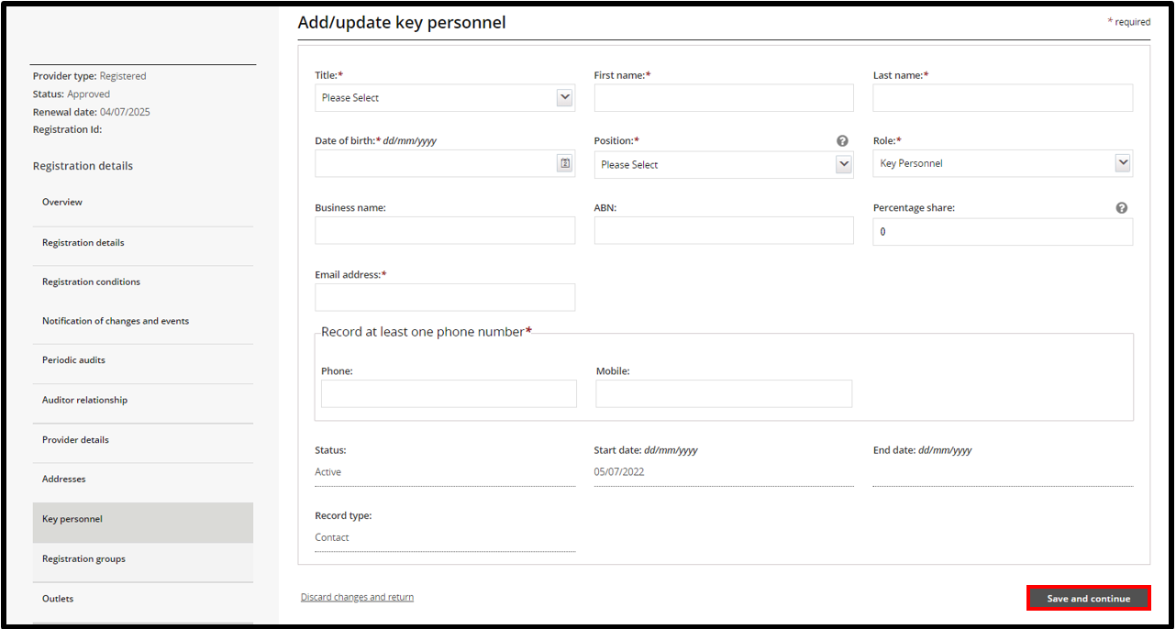
- Select Update to answer all 7 suitability question for the key personnel added
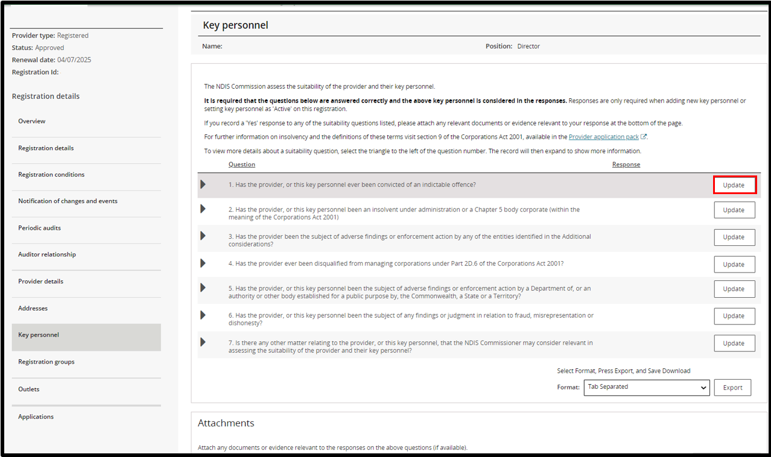
- Complete the Response box by using the drop down and select Yes or No. To add more information to the Provider details box click in the box and start typing. Select Save and return to go back to the list of question. Select Save and continue to move to the next question
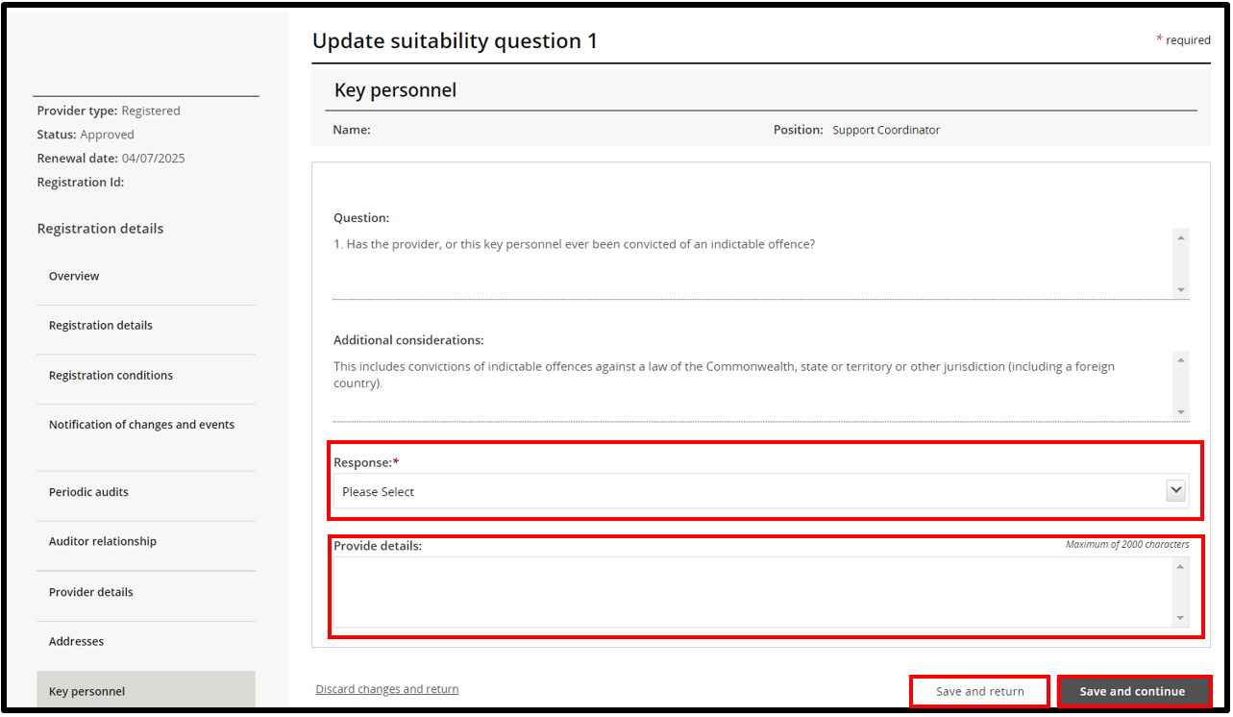
- Once all questions have been answered, add any relevant document by selecting Add attachment. Read the declaration and select Submit and return to complete
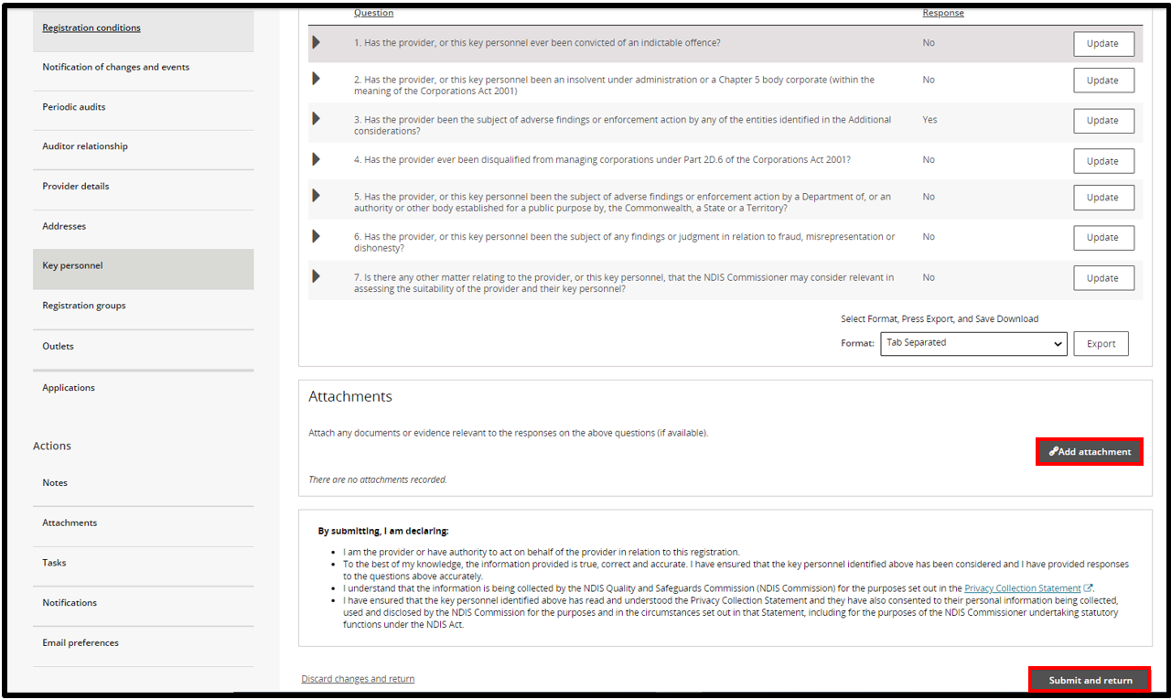

Update/manage a key personnel
- In the key personnel window, select Actions then select an option from the drop down list. You can View, Update, Make primary or Set as inactive any selected key personnel
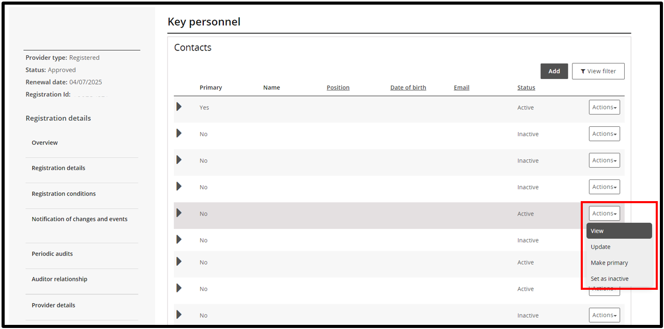
- To view the details of the key personnel, click View (shown in slide 9). The personnel details are displayed. To update the details on record for the key personnel, click Update or select update from the Actions drop down (shown in slide 9)
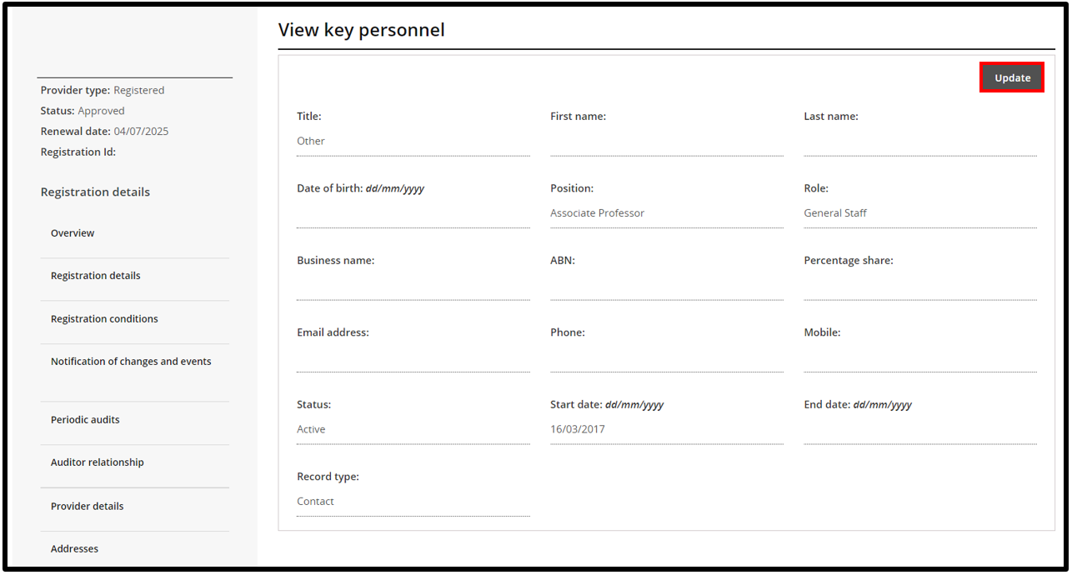
- To make a key personnel the primary contact, select Make primary. This option only appears if the key personnel selected is not currently a primary contact. You can only have one primary contact
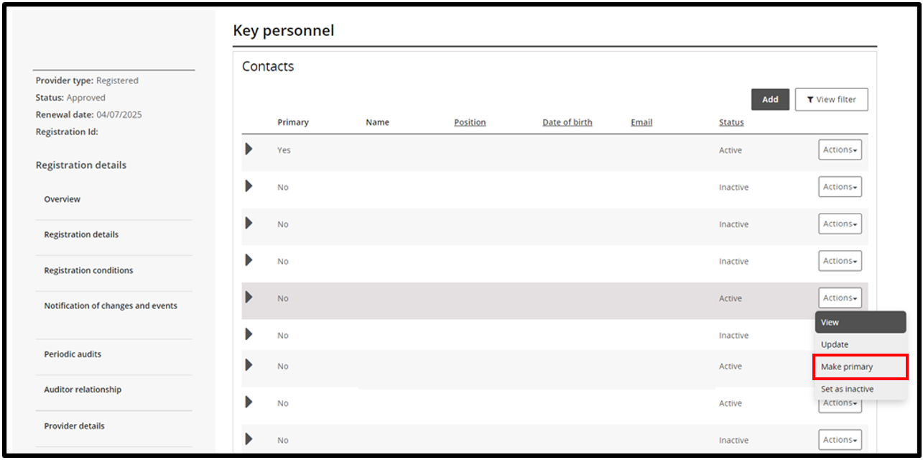
- To make a key personnel inactive select Set as Inactive. Once a person is made inactive, they cannot be made active again. However, they can be added again as a new key personnel
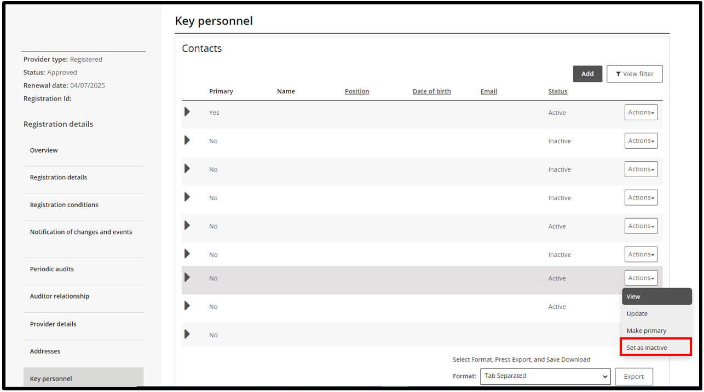
End.

