How to complete a 13/13A notification –registered NDIS providers
Quick reference guide – Provider registration

Since 1 January 2020, as a registered NDIS provider, it is a condition of your registration to notify the NDIS Quality and Safeguards Commissioner of certain changes and events, especially those that substantially affect your ability to provide the supports and services you are registered to provide.
Sections 13 and 13A of the NDIS (Provider Registration and Practice Standards) Rules 2018 set out these requirements. The NDIS Commissioner has made Guidelines to help you understand the types of changes and events you must notify us about.
Further information can be found on the NDIS Commission website here https://www.ndiscommission.gov.au/providers/notice-changes-events
Note: Providers can update their information through the NDIS Portal Commission Portal, using the quick reference guides for provider found here https://www.ndiscommission.gov.au/resources/fact-sheets-and-guides/ndis-commission-portal-quick-reference-guides

Go to the ‘My registration’ tile
- Log in to the NDIS Commission Portal using the Registrant user role.
- Select My registration.
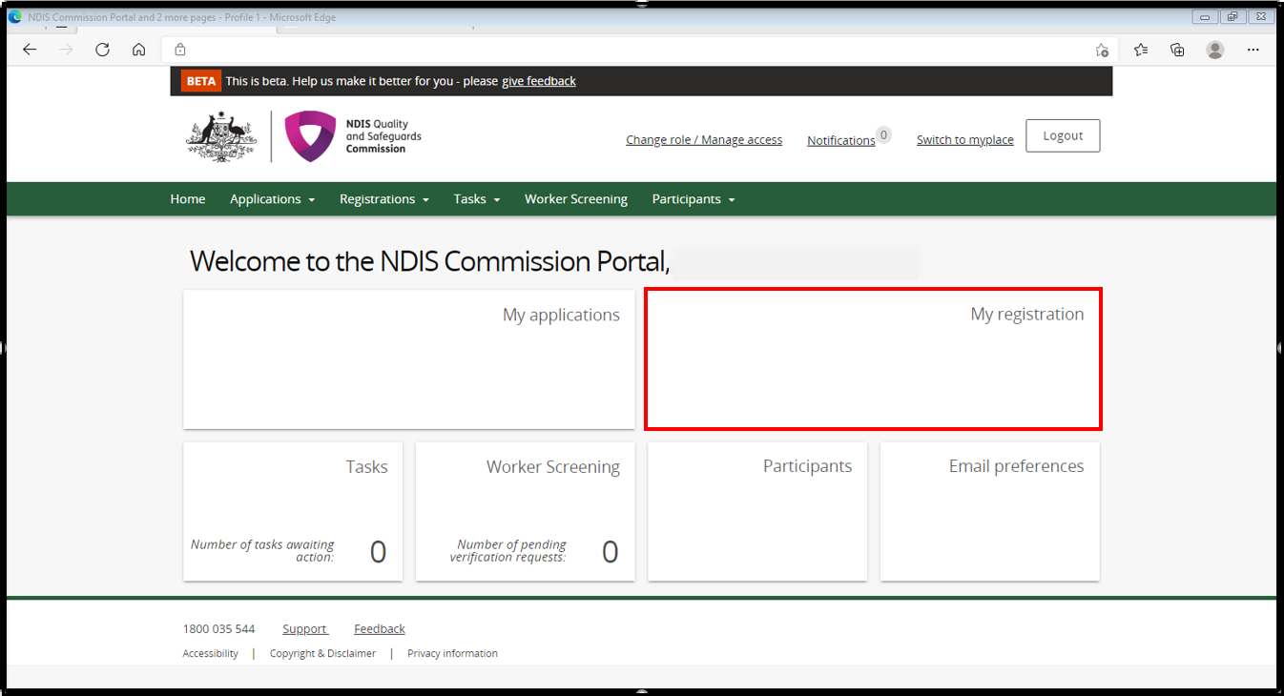

Create your notification
- Select Notification of changes and events tab and select Add.
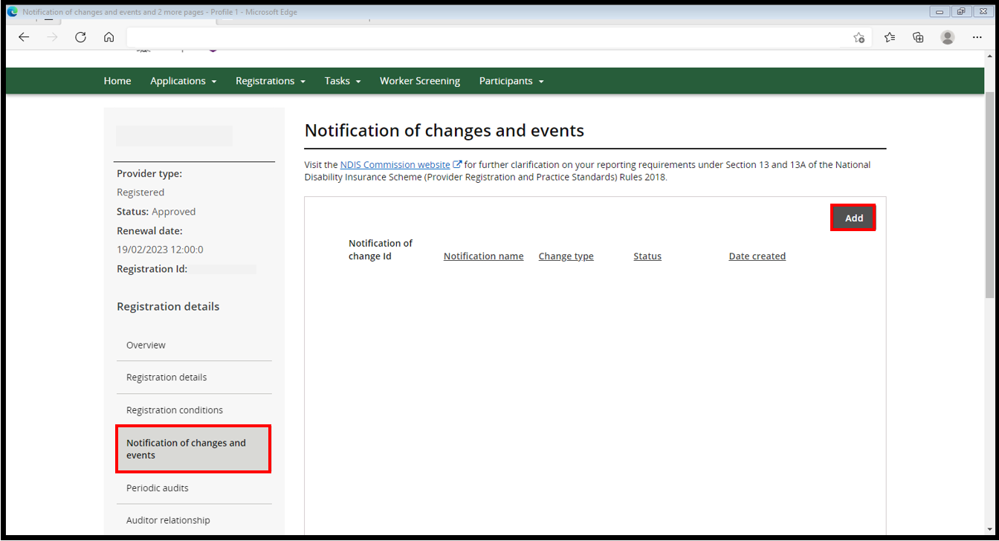
- In the Add/update notification of change or events screen, complete the details in the boxes highlighted below. In the Change type box, use the drop down arrow and select the type of change. In the Notification name box, give your notification a name, eg change of CEO or update Key Personnel. In the Description box, put in a detailed description including dates, full names, reason for change, your email address and contact number.
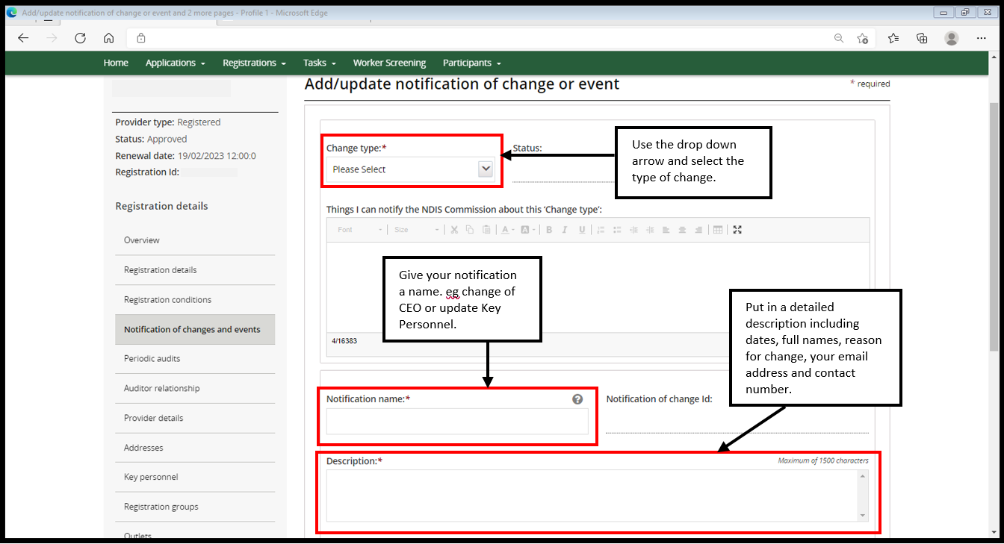
Information that should be included in the description box (if applicable):
- Number of participants impacted
- Number of workers impacted
- Class of supports (registration groups) impacted
- Outlets impacted
- Whether participants who require supports and services have transitioned to an alternate NDIS provider/s of their choice to ensure continuity of supports
- Whether participants / workers have been notified of the change or event
- Whether the National Disability Insurance Agency (NDIA) has been advised of the change or event
- Evidence of change to key personnel, including when the change occurred
- Advise by what mechanism the key personnel ceased the role and / or any other role held within the organisation
- Provide information about the process of change in key personnel, including reasons why the change occurred and information regarding the sale of business (if applicable), change in entity structure or change in shareholders.
- In the same screen, scroll down and add attachments by selecting Add attachment and include any supporting documentation. When you are ready to submit your notice select Submit and return. If you need to exit your notice and come back to it later you can select Save. This will save your notice without submitting it.
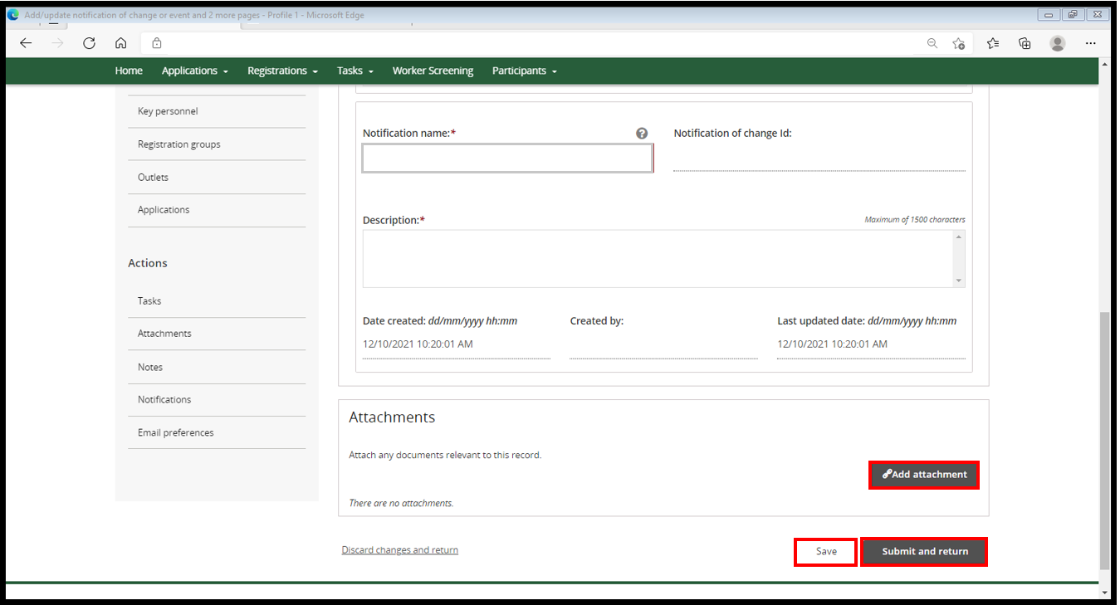
- Once you have saved or submitted your notification, you can view them in the Notification of changes and events screen. The status will show you if your notification has been submitted or is in progress. Select Action and then select View to continue progressing your notification, or to view your submitted notification.
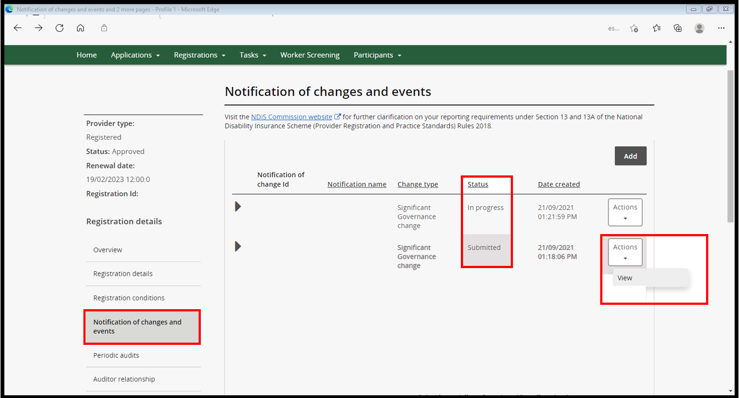
Note: Your notification has not been lodged with the NDIS Commission if the status is In progress. Select Submit and return in step 5 of this QRG to lodge you notification.
The NDIS Commission will contact the notifier and/or primary contact via email about the notification and any further information or documents that may be required.
End.

