How to withdraw a new or renewal application
Quick reference guide – Provider registration and Applicants
Providers can withdraw a new application in the Application Portal or a renewal application in the NDIS Commission Portal. Applications can be withdrawn while in the status of: ‘Draft’ or ‘Submitted’. Applications in the ‘In progress’ status can also be withdrawn provided the Auditor status is not in ‘Submitted to Commission’.

Login to the Application Portal for a new application and the Provider Portal for a renewal application.

New applications
- In the Application Portal, select ‘New application to be registered as an NDIS Provider’ tile.
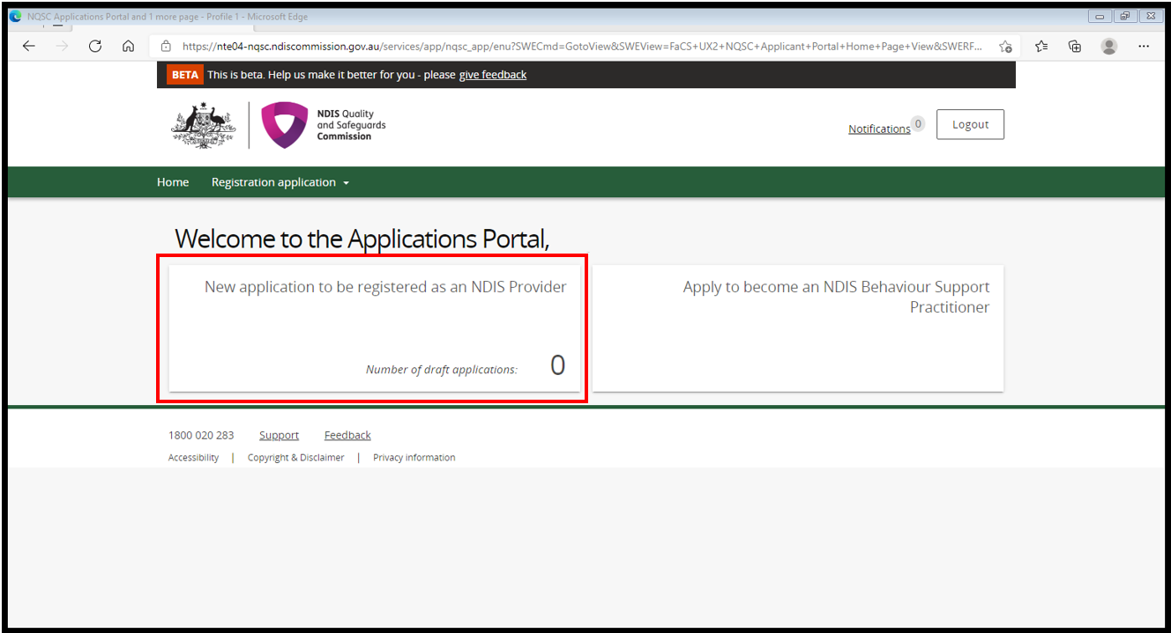
- To view your application select the ‘Action’ button and then select ‘View’.
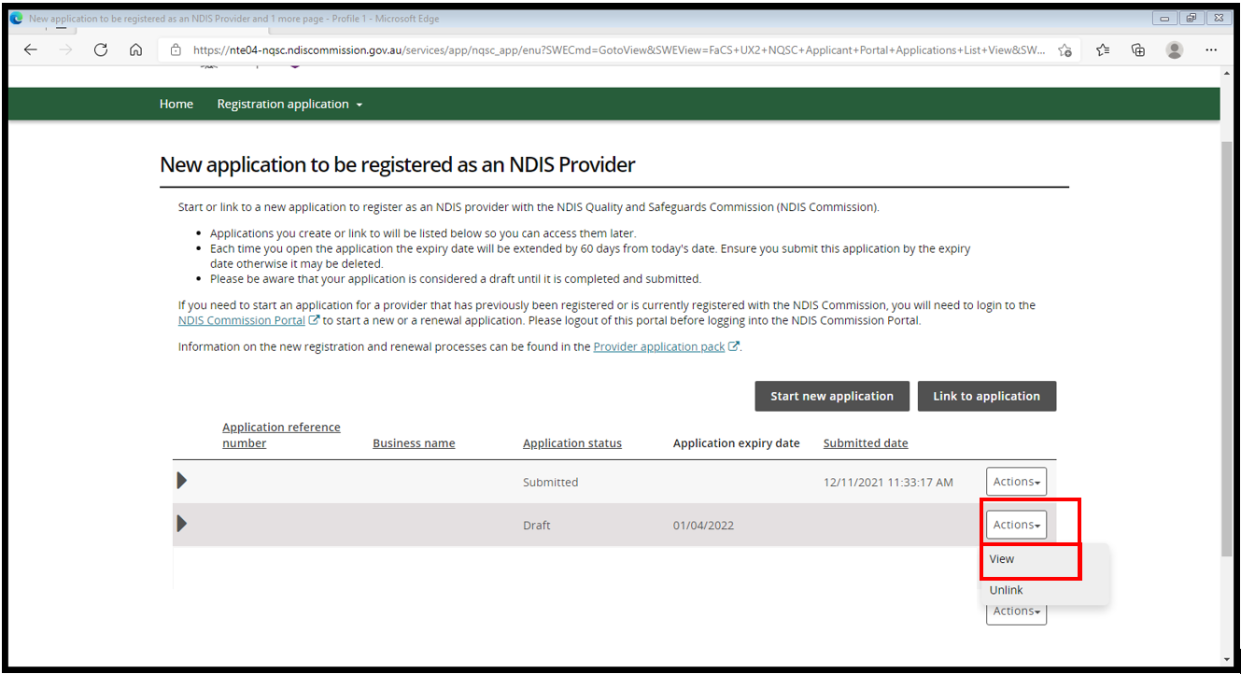
- For a new application, with an application status of draft, you will see the ‘Withdraw application’ button in the ‘Application information’ tab. Select the ‘Withdraw application’ button if you no longer wish to continue with your new application.
Draft view
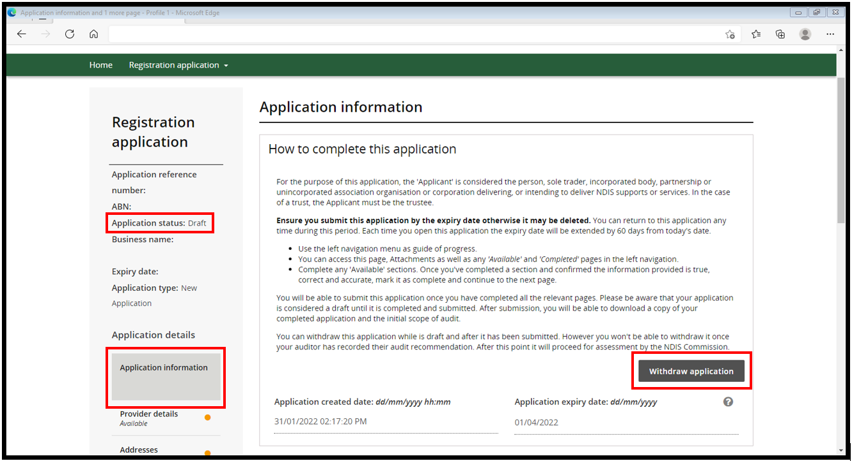
- A ‘Confirm withdraw application’ box will appear. Read the text and select the ‘Confirm’ button to continue with your withdrawal. Once confirmed your new application will be withdrawn and the application status will be updated.
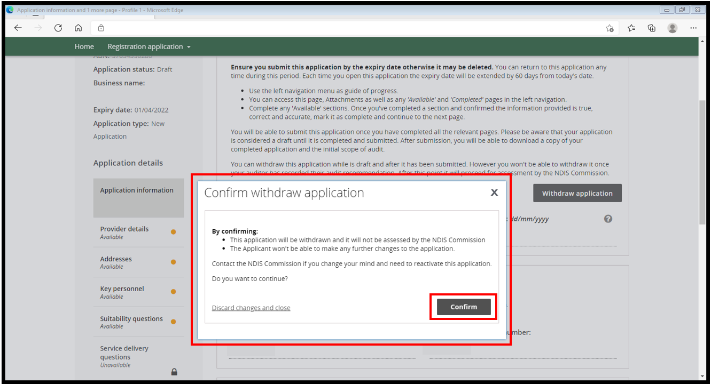
- For a new application, with an application status of ’Submitted’ or ‘In progress’, you will a see the ‘Withdraw application’ button on the first screen after you view the application. The ‘Application Submitted ‘screen. Select the ‘Withdraw application’ button if you no longer wish to continue with your new application.
Submitted view
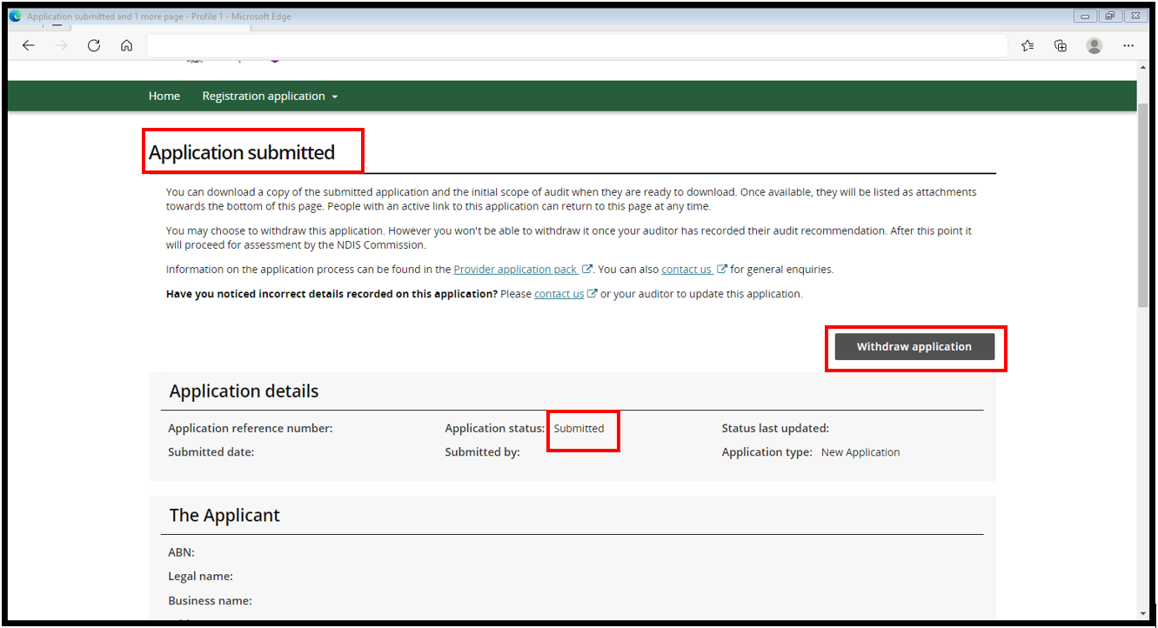
In progress view
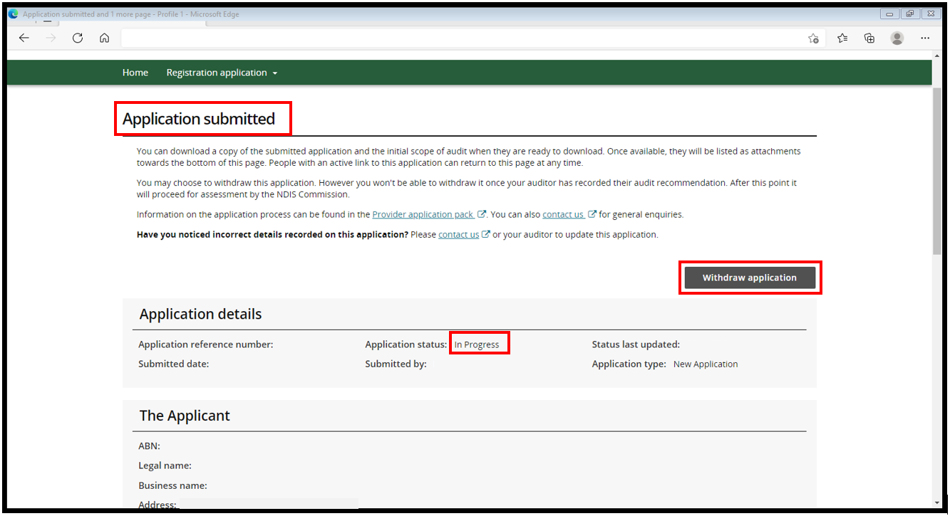
- A ‘Confirm withdraw application’ box will appear. Read the text and select the ‘Confirm’ button to continue with your withdrawal. Once confirmed your new application will be withdrawn. The application status will be updated to withdrawn.
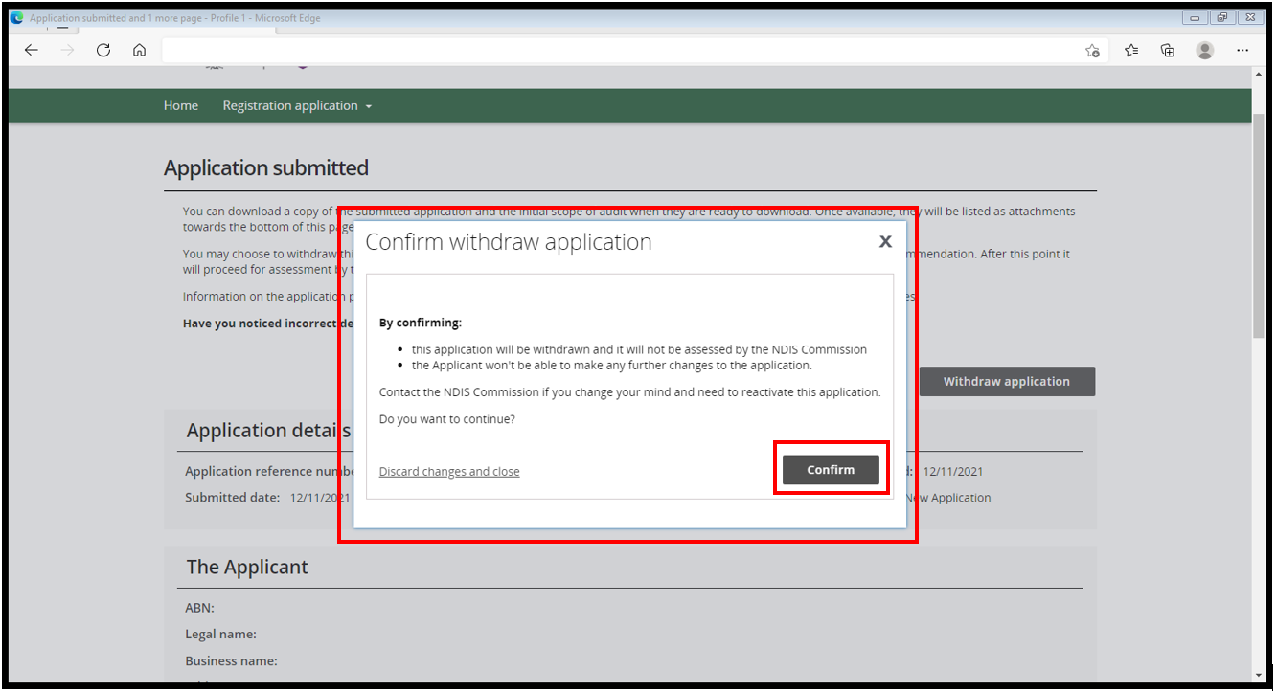

Renewal applications
- In the ‘NDIS Commission Portal’, select the ‘My applications’ box.
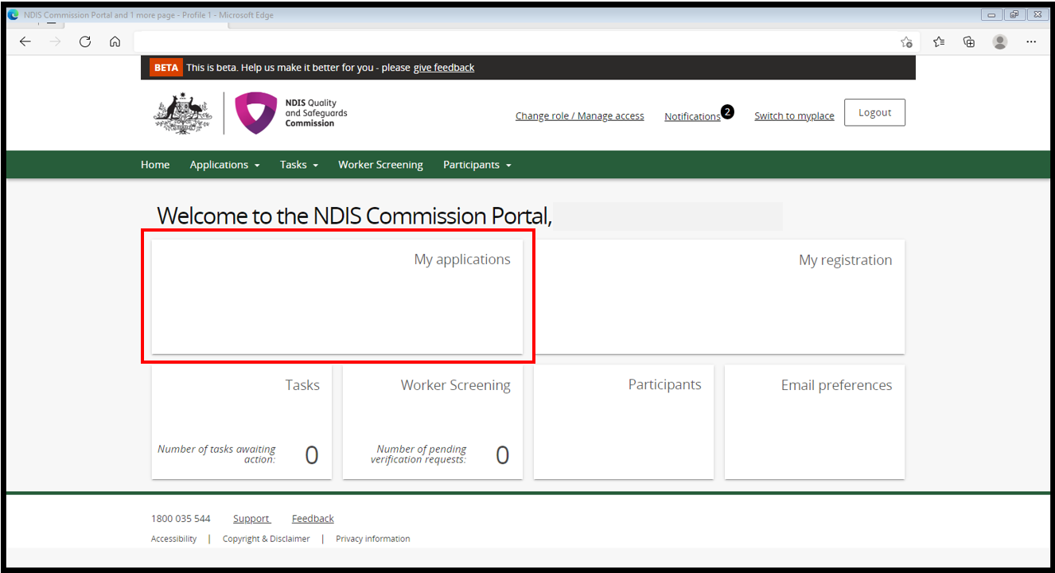
- To view your renewal application select the ‘View’ button.
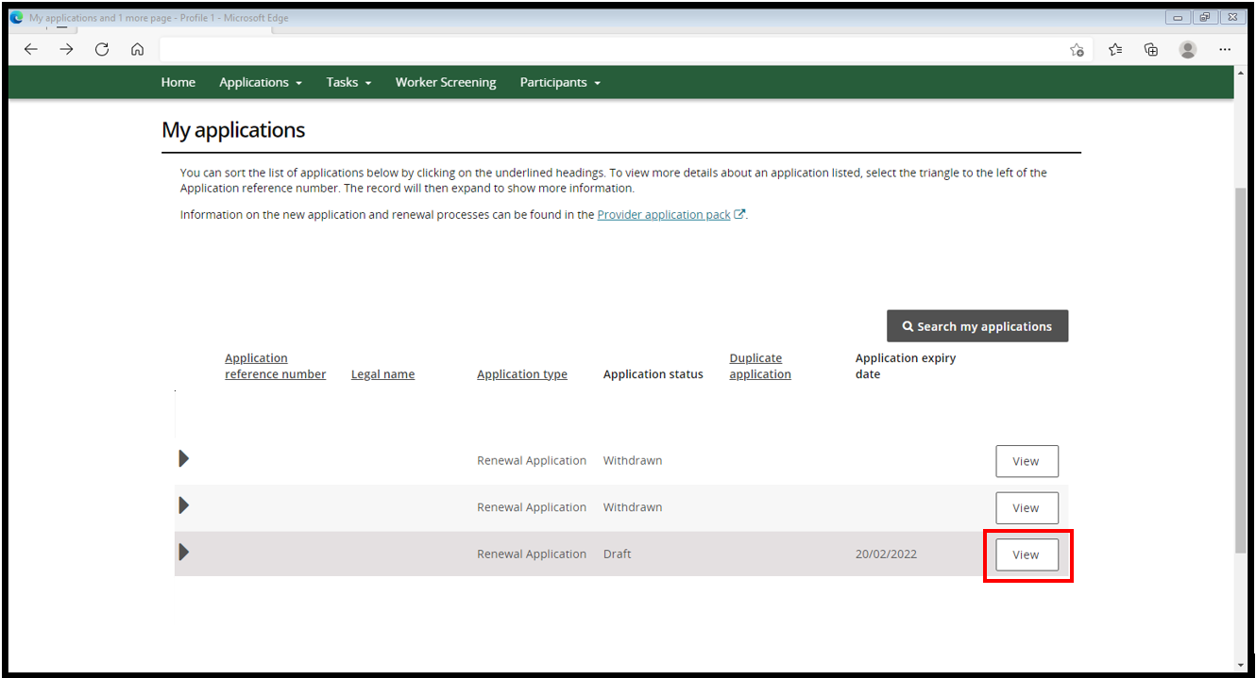
- For a renewal application, with an application status of ‘Draft’, you will see the ‘Withdraw application’ button in the ‘Application information’ tab. Select the ‘Withdraw application’ button if you no longer wish to continue with your renewal application.
Draft view
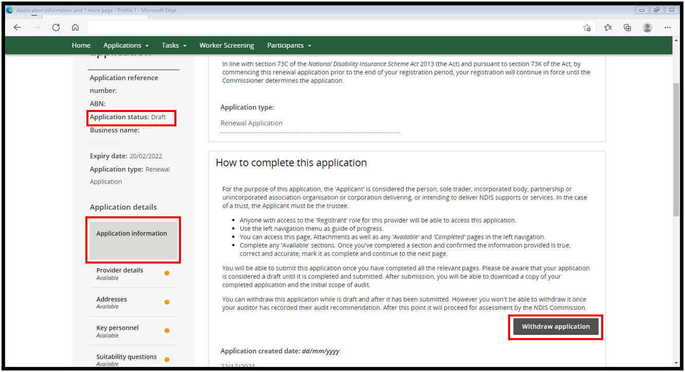
- A ‘Confirm withdraw application’ box will appear. Read the text and select the ‘Confirm’ button to continue with the withdrawal. Once confirmed the Commission will make contact with you before withdrawing your application. The application status will not change at this time.
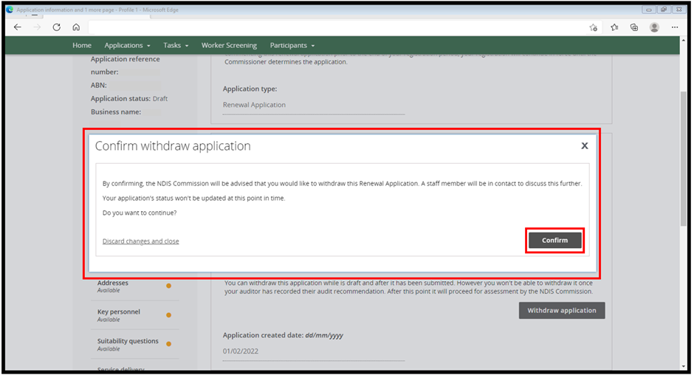

- For a renewal application, with an application status of ‘Submitted or In Progress’, you will a see the ‘Withdraw application’ button on the first screen after you view the application in the ‘Application details’ tab. Select the ‘Withdraw application’ button if you no longer wish to continue with your Renewal application.
Submitted view
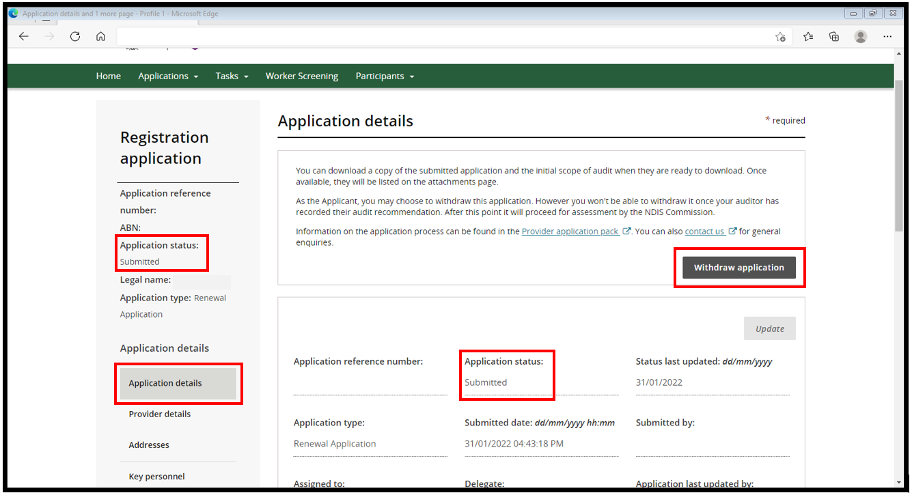
In Progress view
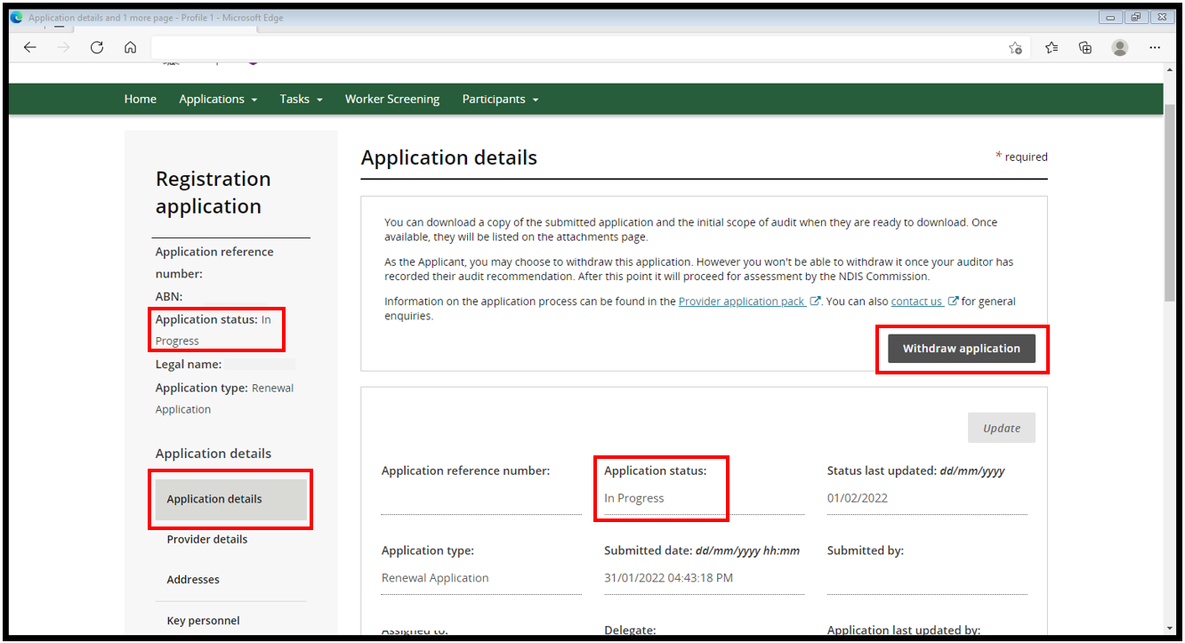
- A ‘Confirm withdraw application’ box will appear. Read the text and select the ‘Confirm’ button to continue with the withdrawal. Once confirmed the Commission will make contact with you before withdrawing your application. The application status will not change at this time.
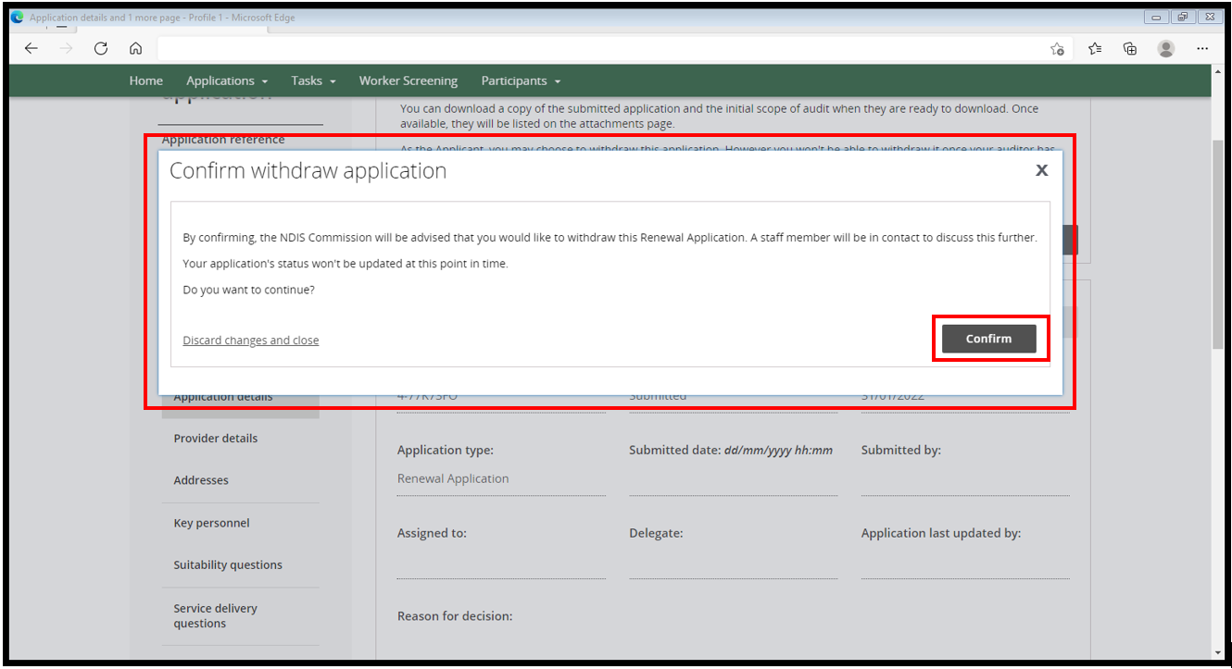

End.

