NDIS behaviour support to Practitioners
  - Quick reference guide – Responding to Request For Information through the Applications Portal

Practitioners applying to become an NDIS Behaviour Support Practitioner may have received a Request For Information email for their application. This Quick Reference Guide explains the step-by-step process of completing the Request For Information task through the Applications Portal.

In this guide
- Logging in to the Applications Portal
- Completing a Request For Information task
- Help with accessing the Applications Portal if access is denied

Logging in to the Applications Portal
- Click Portals. Select Applications Portal.
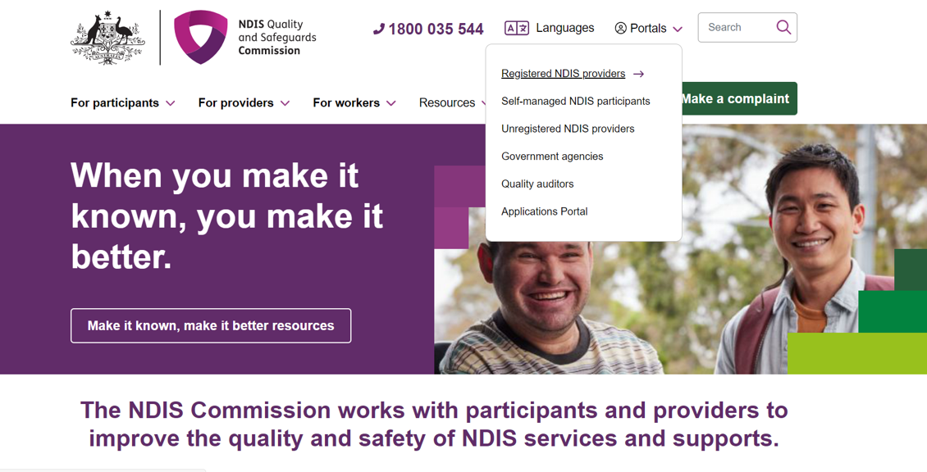
- Click Login with PRODA.
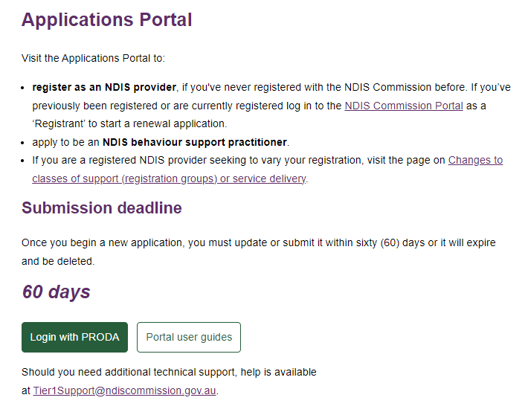
- Type the PRODA Username and Password then click Login.
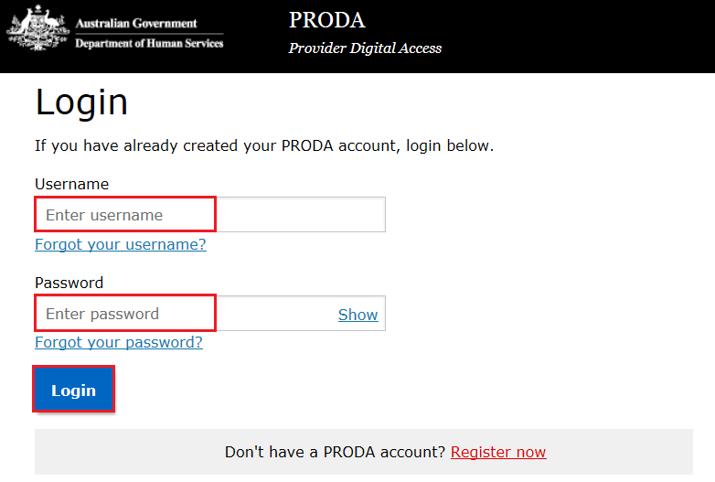
- Enter the PRODA verification Code then click Next.
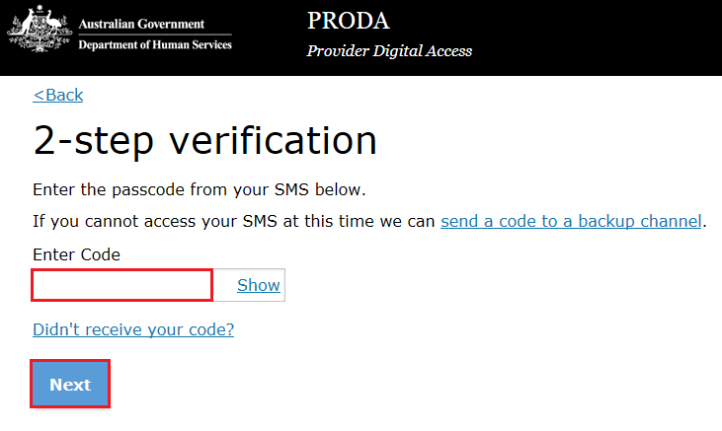

- Select I agree. 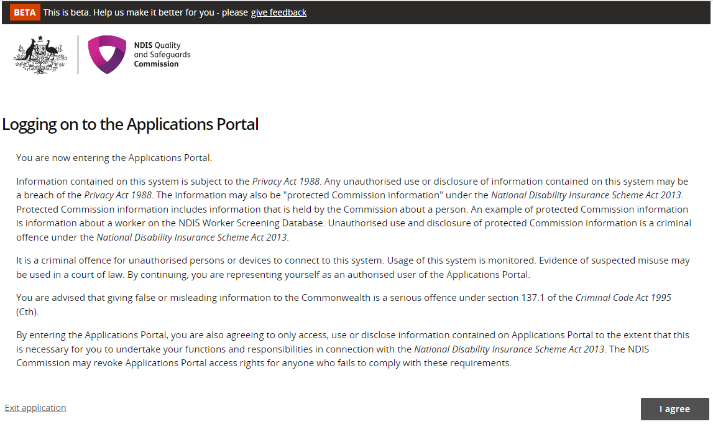
This should successfully log you on to the Applications Portal.

Completing a Request For Information task
- Click Apply to become an NDIS Behaviour Support Practitioner.
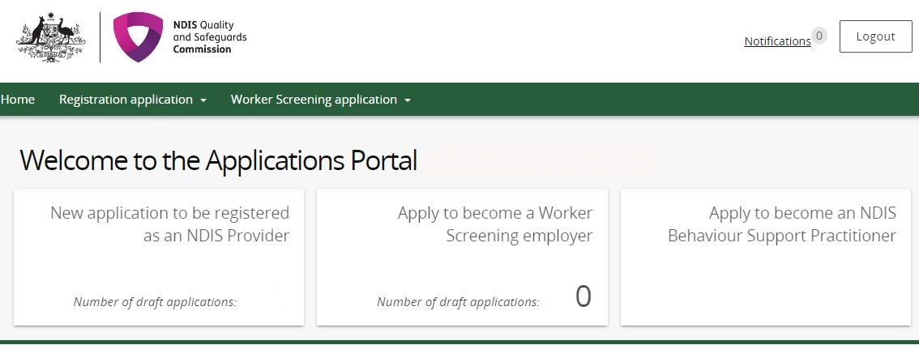

- If your Application status is in Information request, click Actions then View.
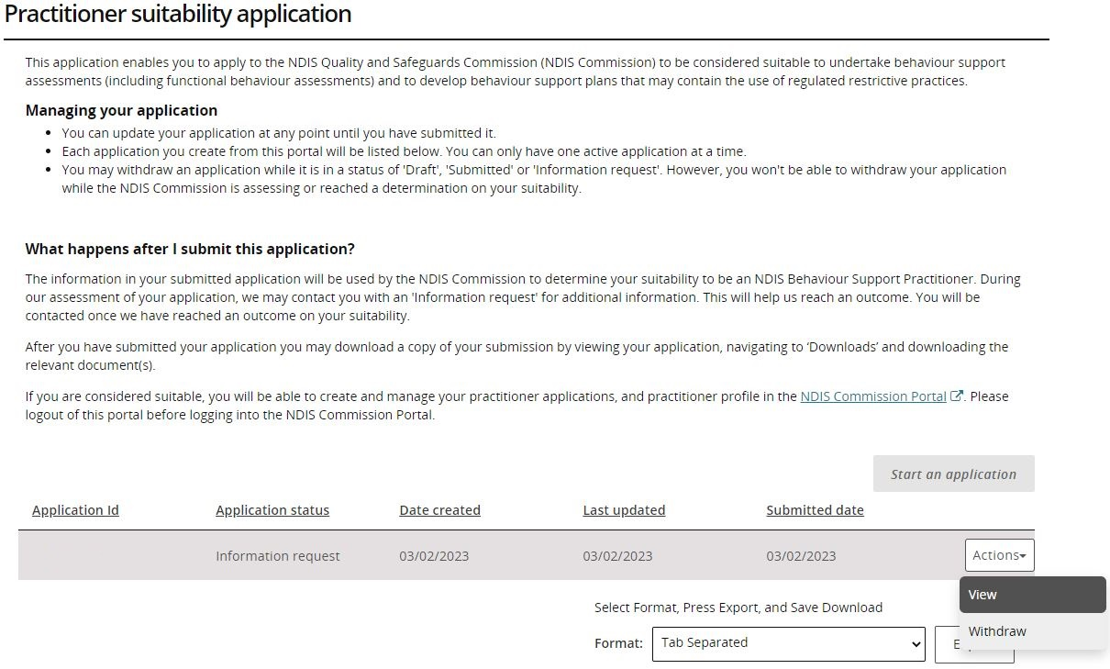

- Click Information requests, on the left hand side menu.
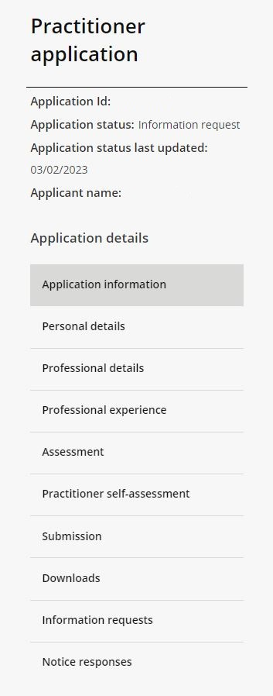

- Click Actions then Update.
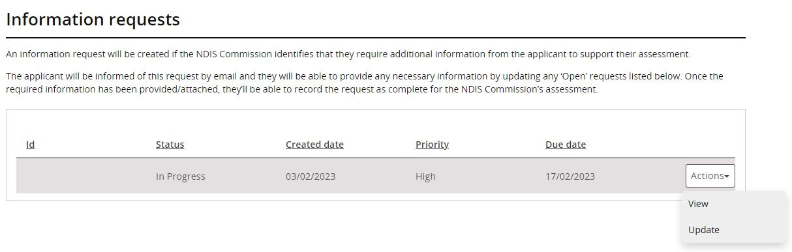

- Read the “Additional information required” to see what information is requested. Once read, please write a response in “Applicant’s response” and click Add attachment for the requested documents.
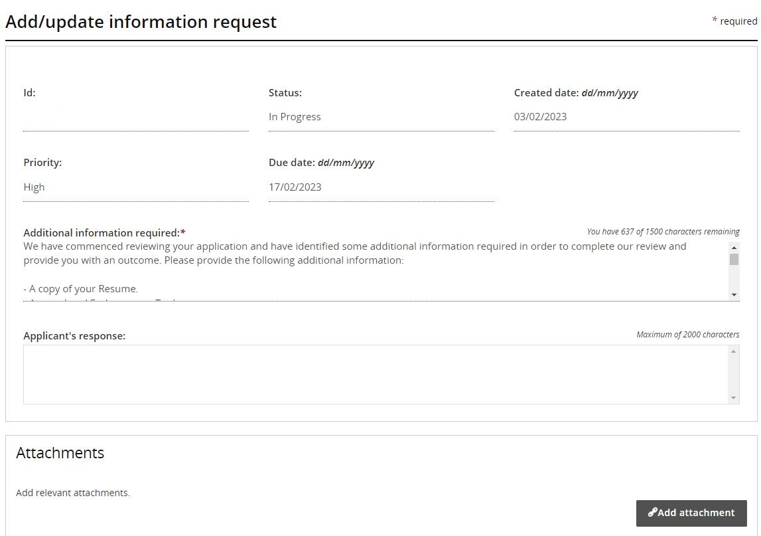

- Select the document you want to attach to the information request task and click Save and close. Please note that this step needs to be completed for each document.
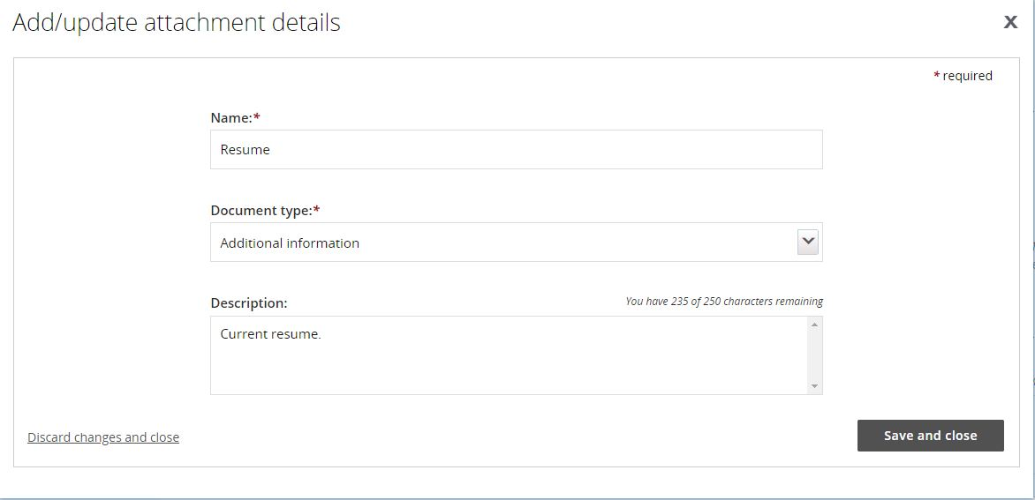

- When all documents have been attached, click Complete request.
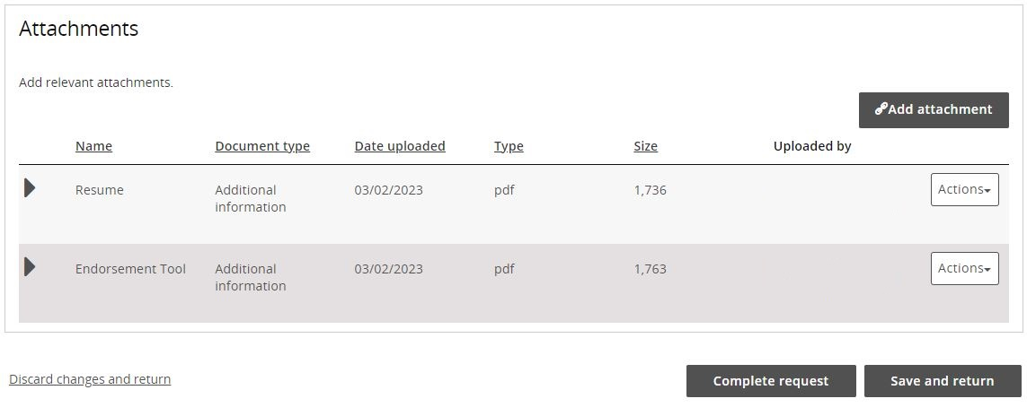

- Check that the status of the Information request has changed to “Done”.
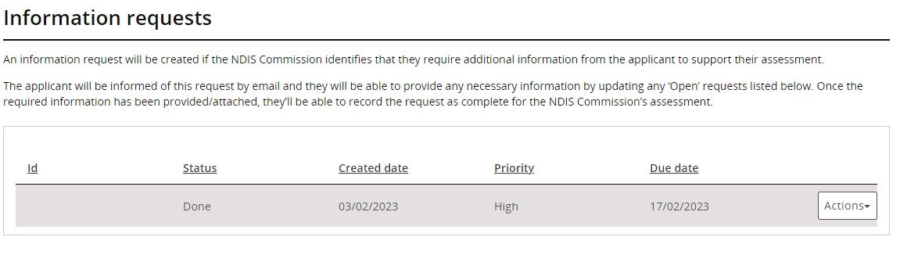
You have now completed your Request For Information task.

Help with accessing the Applications Portal if access is denied
If you see the below after logging in via PRODA, please follow these next steps:
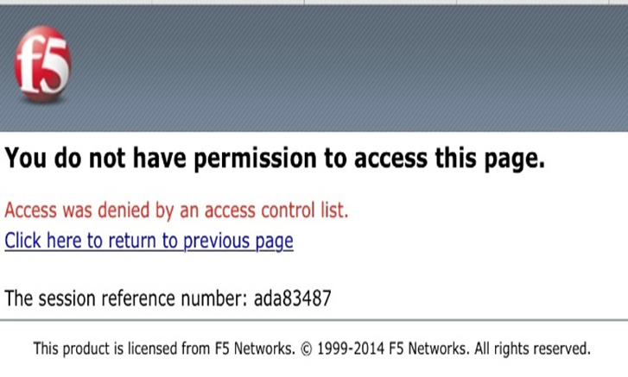

- Ensure that you are using Microsoft Edge for PC or Google Chrome for MacBook.
- Go to your browser’s settings.
- Delete your browser’s cache.
- Attempt to login to the Applications Portal again.
- You have successfully logged into the Applications Portal.

Further information or support
Contact the NDIS Quality and Safeguards Commission
Phone: 1800 035 544 (Mon-Fri)
Email: ndispractitioners@ndiscommission.gov.au

