Provider portal inbox
Quick reference guide – Provider registration
This quick reference guide provides information about how to access and manage messages in your NDIS Commission Provider Portal Inbox.

Inbox notification
- When you receive a message in your NDIS Commission Portal Inbox you will receive an email alert about the message
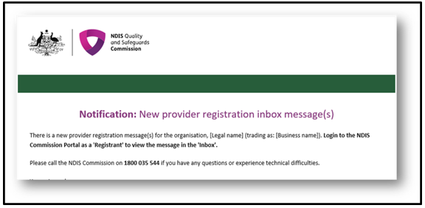
- The representatives that will receive the email alert are those with email addresses recorded in the ‘Registration’ section of email preferences. If there are no email addresses recorded in the Registration recipient(s), the Default recipient(s) will receive the email alert
- Email alerts are sent at periodic times throughout the day. If an inbox message is read before the email alert about that message is sent, an alert won’t be sent

Access the Inbox
- Go to the NDIS Commission Website and select the Portals button and select Registered NDIS providers option
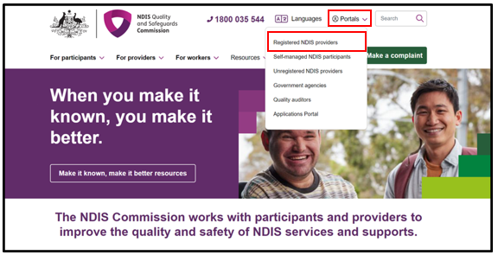
- Select Login with PRODA
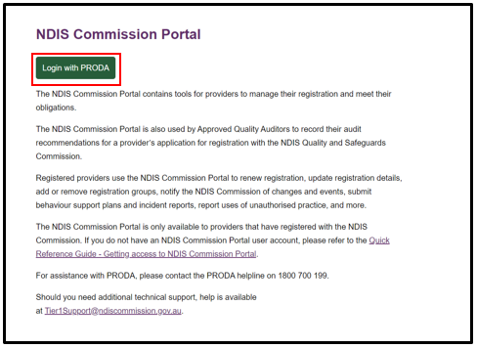
- Enter your Username and Password. Select Login
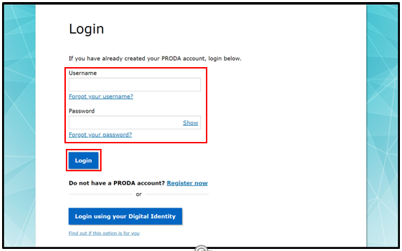
- Enter your verification code. Select Next
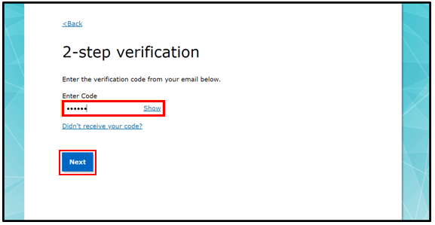
- At the Portal entry point, select the Provider name of the registered NDIS provider that you are logging into the NDIS Commission Portal on behalf of. Select Registrant as the Role. Select Continue
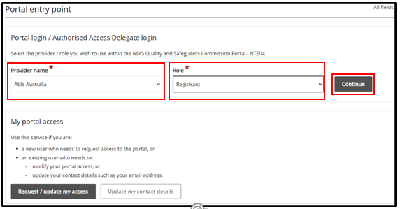
- Select the Inbox tile
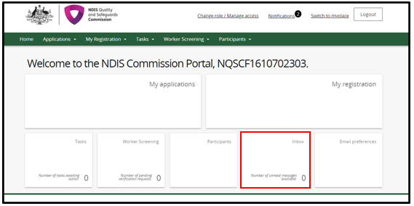
- The inbox will open and you will see the below Inbox screen with any messages listed
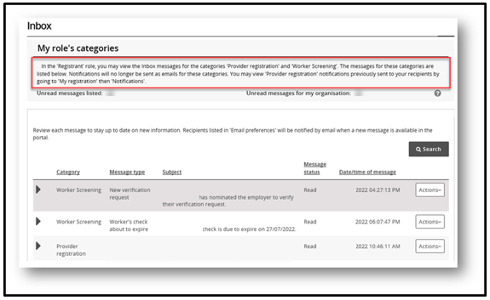
Note: You can view Provider registration notifications previously sent to your registration by going to My registration then selecting the Notifications tab

View inbox messages
- To view a message details select Actions and View
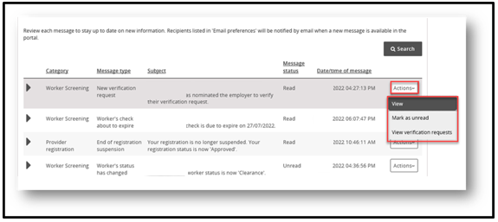
- Information about the message, such as who has viewed it and what email addresses received the email alert can be viewed
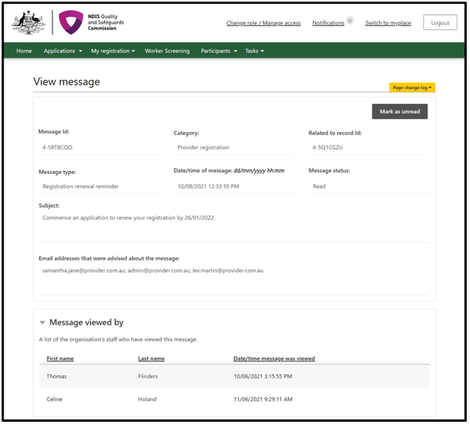
- The message will appear at the bottom of the page. Use the buttons along the top of the message to expand or print the message. If the message requires an action, the action button will appear. By selecting the action button you will be taken to the required COS screen to action
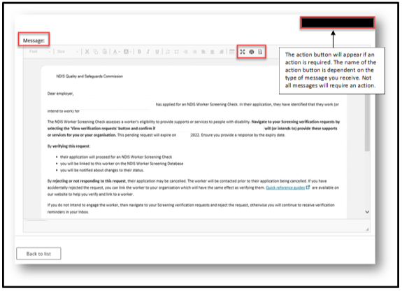

Search or filter messages
- Use the filter drop down option to select All, Read or Unread messages in your inbox. Select Apply filter
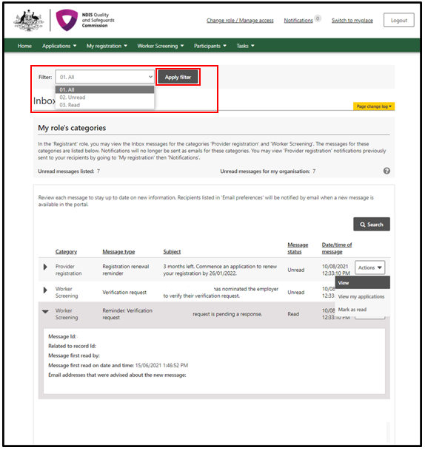
- Use the Search messages function to display only particular messages e.g. all messages about Registration or Worker Screening (depending on your role). Select the Category and then select the Message type. Select Run search
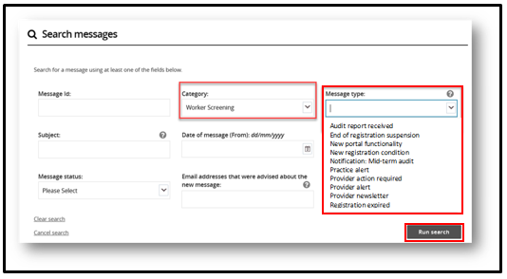

Identify who has viewed a message
- Expand the message in the inbox using the twistie arrow to view Message first read by and at what date/time. The Email addresses advised of the message lists those email addresses that received the email alert about the message being available in the inbox
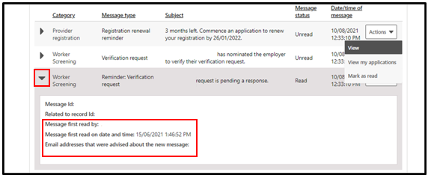

Managing email preferences
- Log into PRODA and select ‘Registrant’ to access the NDIS Commission Portal.
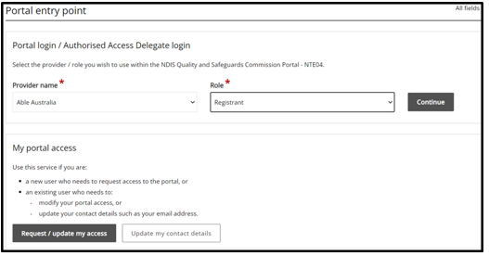

Select the ‘Email preferences’ tile to manage who will receive emails, and what types of emails each person will receive, from the NDIS Quality and Safeguards Commission on behalf of your organisation.
- A list of category descriptions will display at the top of the screen. This describes the different categories of emails that will be received. For each email contact a category from the list must be selected e.g. these are the types of emails they will receive.
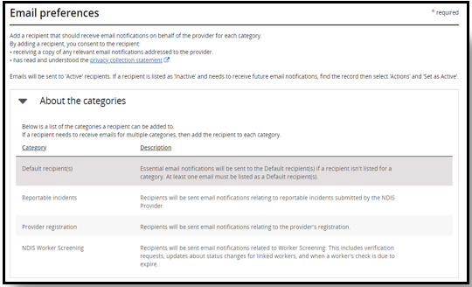
- To add an email contact to the list, select ‘Add’, enter their details and choose the category of emails they will receive. If they require multiple categories, they will need to be added multiple times.
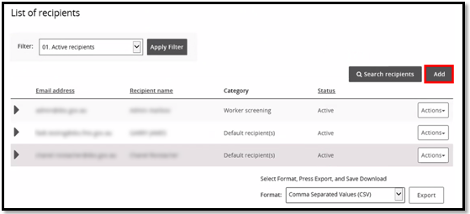
- To remove an email contact, select ‘Action’ and ‘Remove’.
- To update the details of an email contact e.g. change their email category, select ‘Action’ and ‘Update’.

